2019年4月12日共处理逾期行李56件，
保管箱号NO.8062/8018两个集装箱内

- OHD CANCZ90100 仓号19020283
- OHD CANCZ90438 仓号190227149
- OHD CANCZ90325 仓号19022207
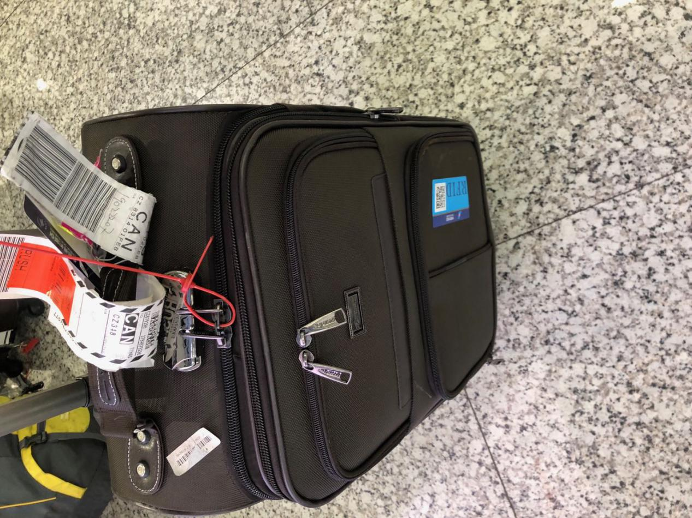
- OHD CANCZ90094 仓号19020258
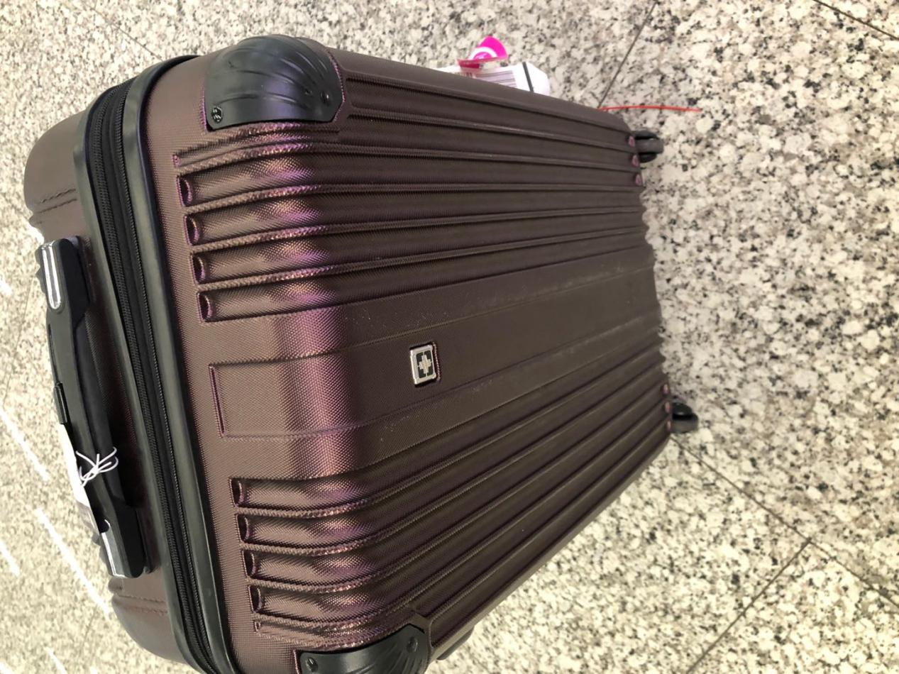
- OHD CANCZ90136 仓号19020630
- OHD CANCZ89761 仓号19011633
- OHD CANCZ90449 仓号19022886
- OHD CANCZ90102 仓号190202110
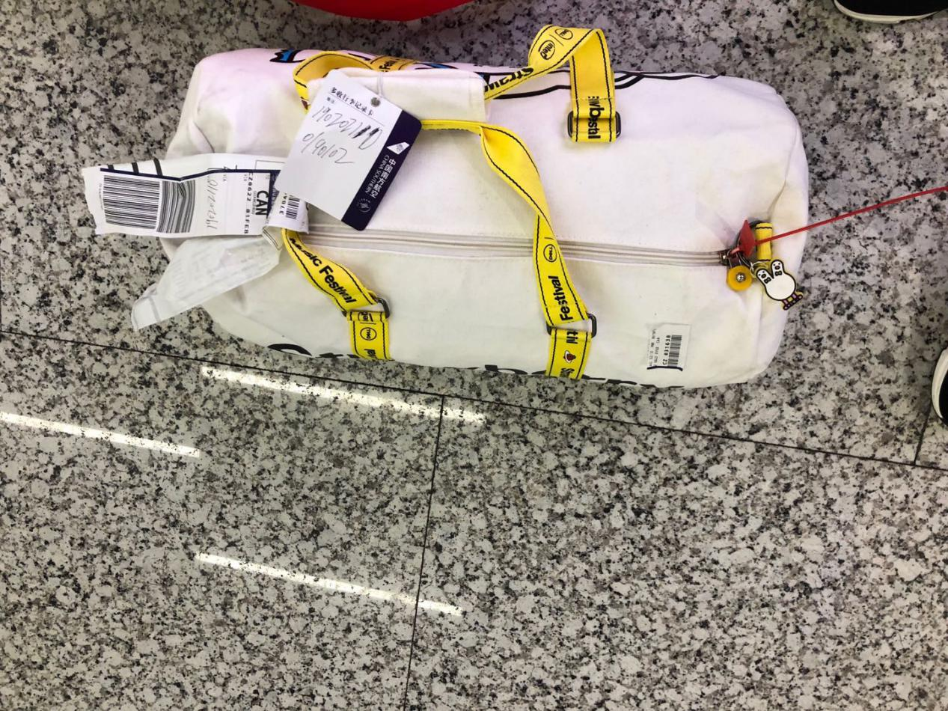
- OHD CANCZ90260 仓号19021681
- OHD 3u10018 仓号19030418
- OHD CANCZ89043 仓号18121318
- OHD CANCZ89944 仓号19012425
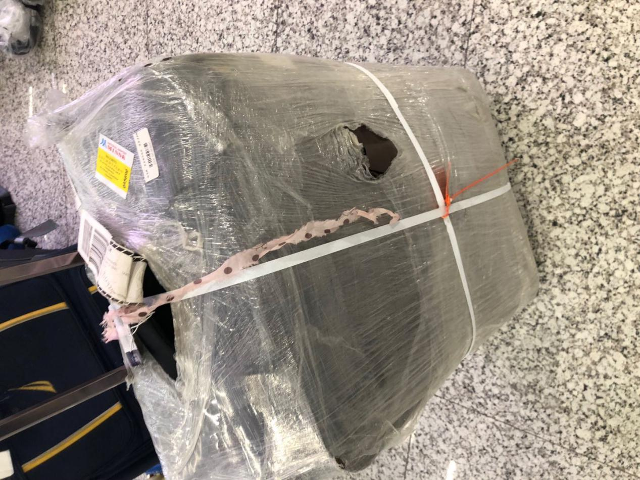
- OHD CANCZ89983 仓号19012741
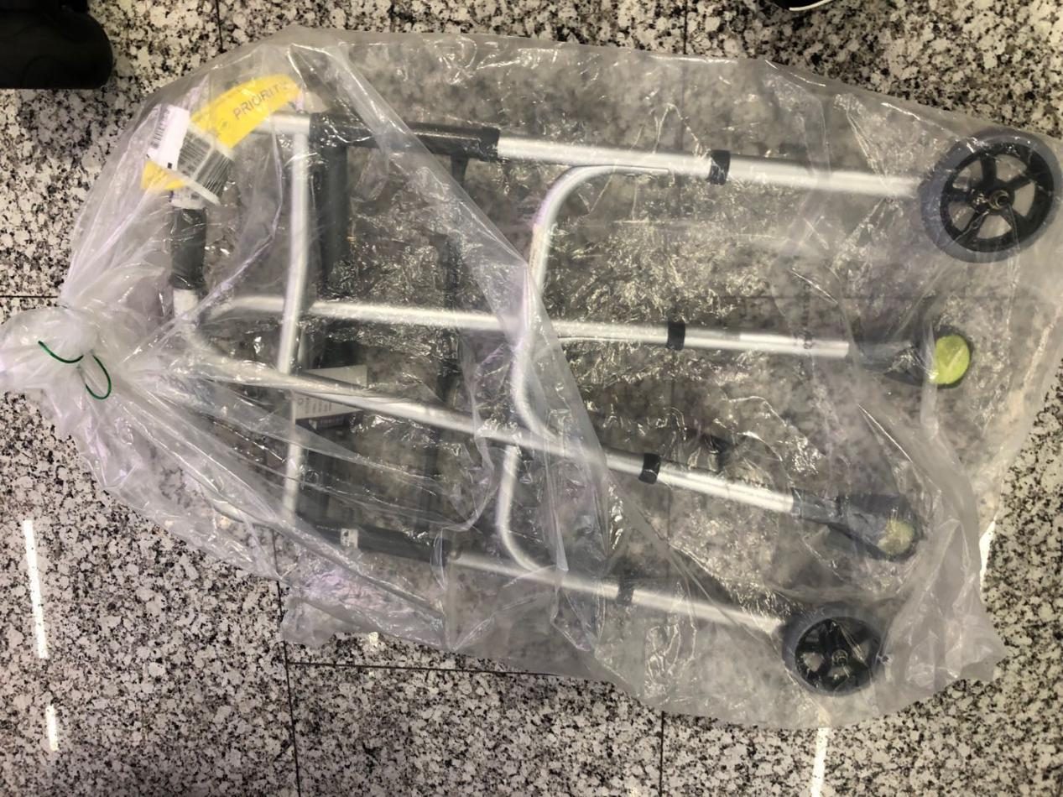
- OHD CANCZ90143 仓号19020715
- OHD CANCZ90265 仓号19021748

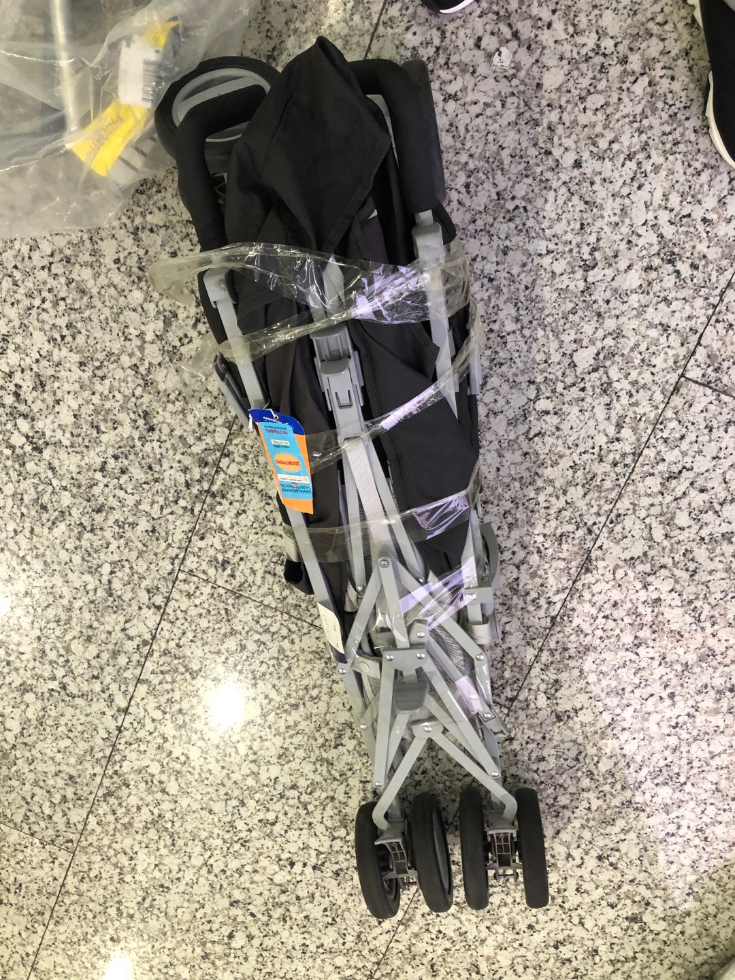
- OHD CANCZ90446 仓号19030157
- OHD CANCZ89852 仓号19012026
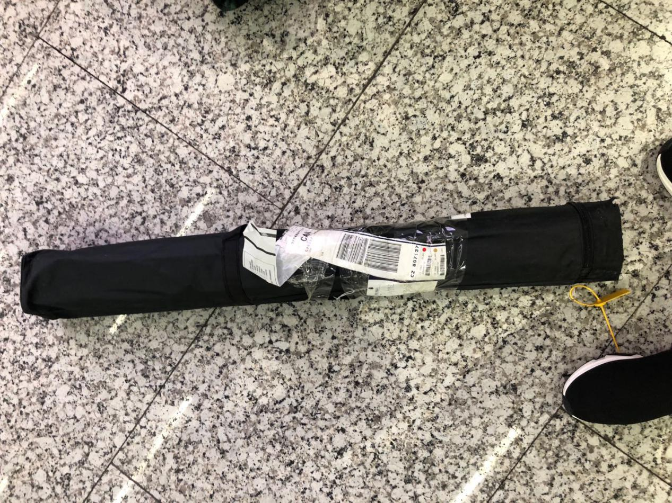
- OHD CANCZ90129 仓号19020584
- OHD CANCZ90118 仓号19020497
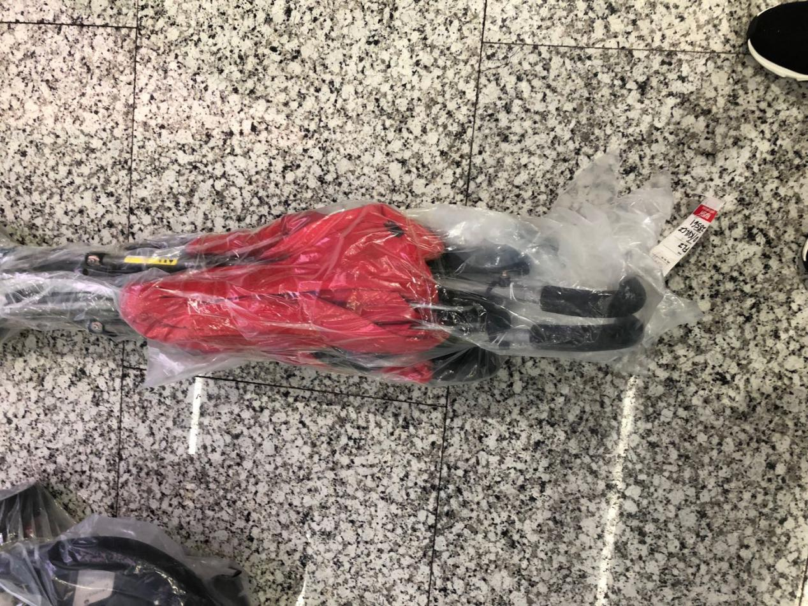
- OHD CANCZ90140仓号19020642
- OHD CANCZ90206 仓号19021268
- OHD CANCZ89115仓号181217158
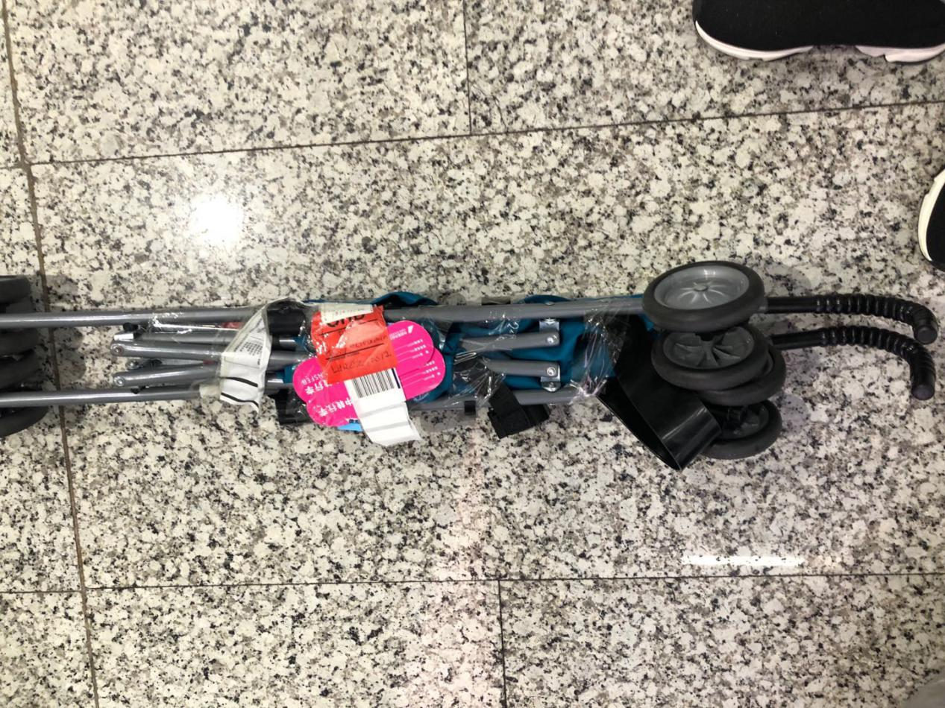
- OHD CANCZ90326 仓号19022210
- OHD CANCZ90441 仓号190227153
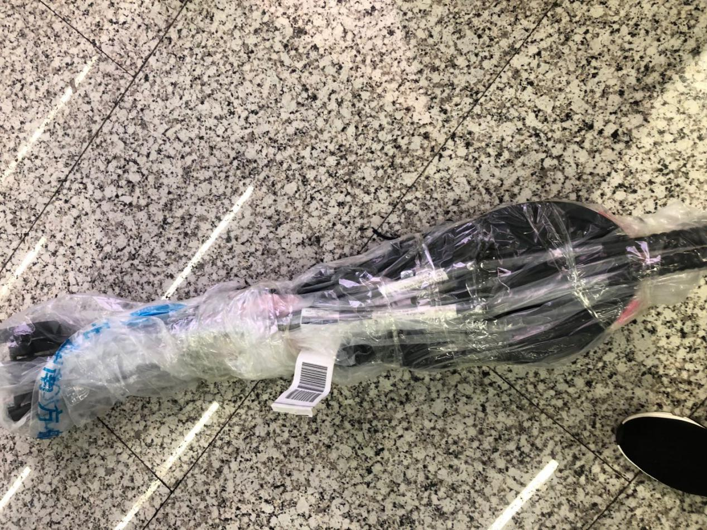
- OHD CANCZ90278 仓号19021764
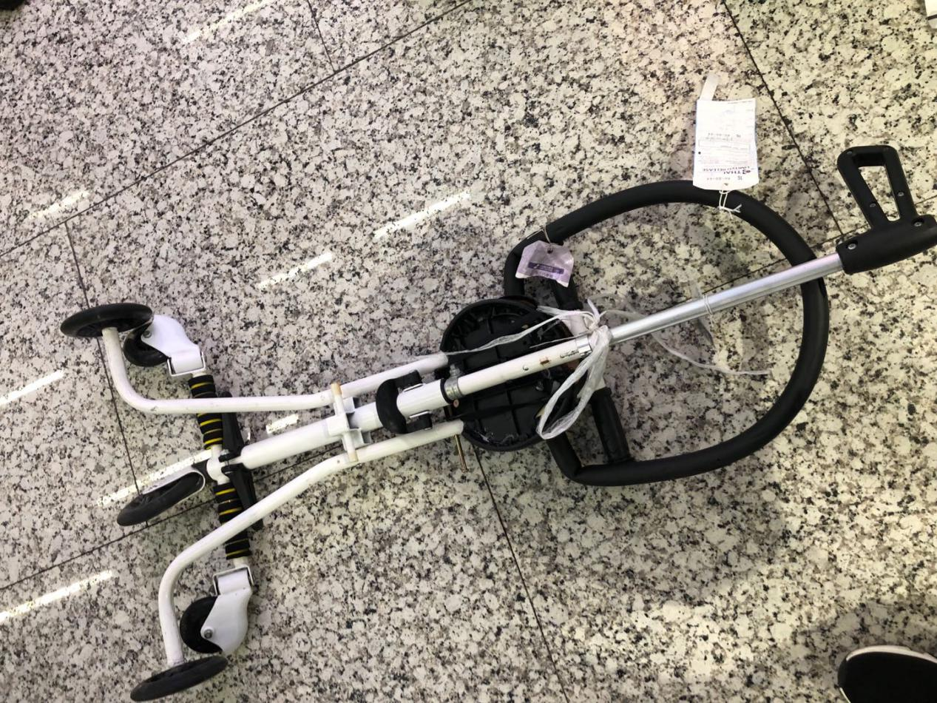
- OHD CANCZ90224 仓号19021412
- OHD CANCZ90467 仓号19030158
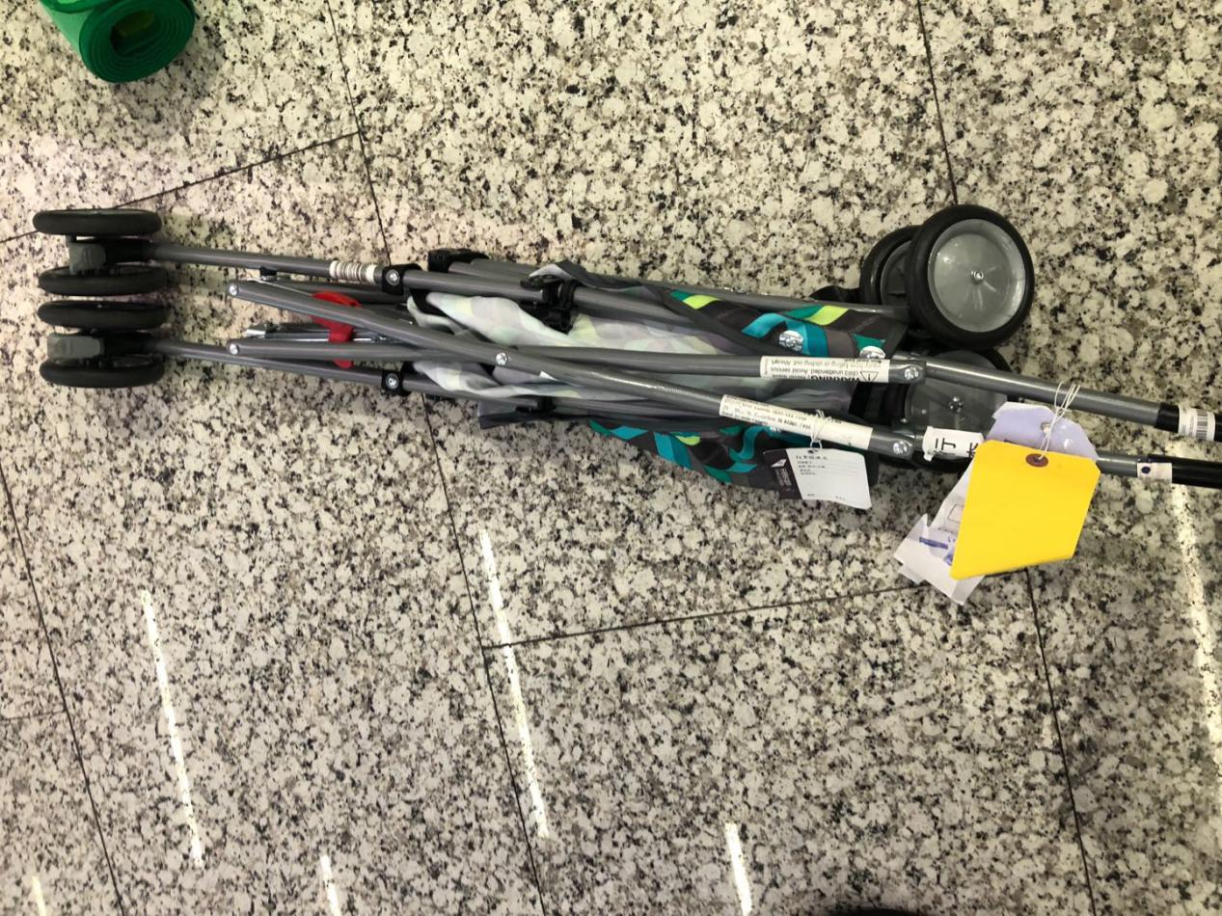
- OHD CANCZ90602 仓号19030714
- OHD CANCZ90445 仓号19022837
- OHD CANCZ90277 仓号19021763
- OHD CANCZ90468 仓号19030159
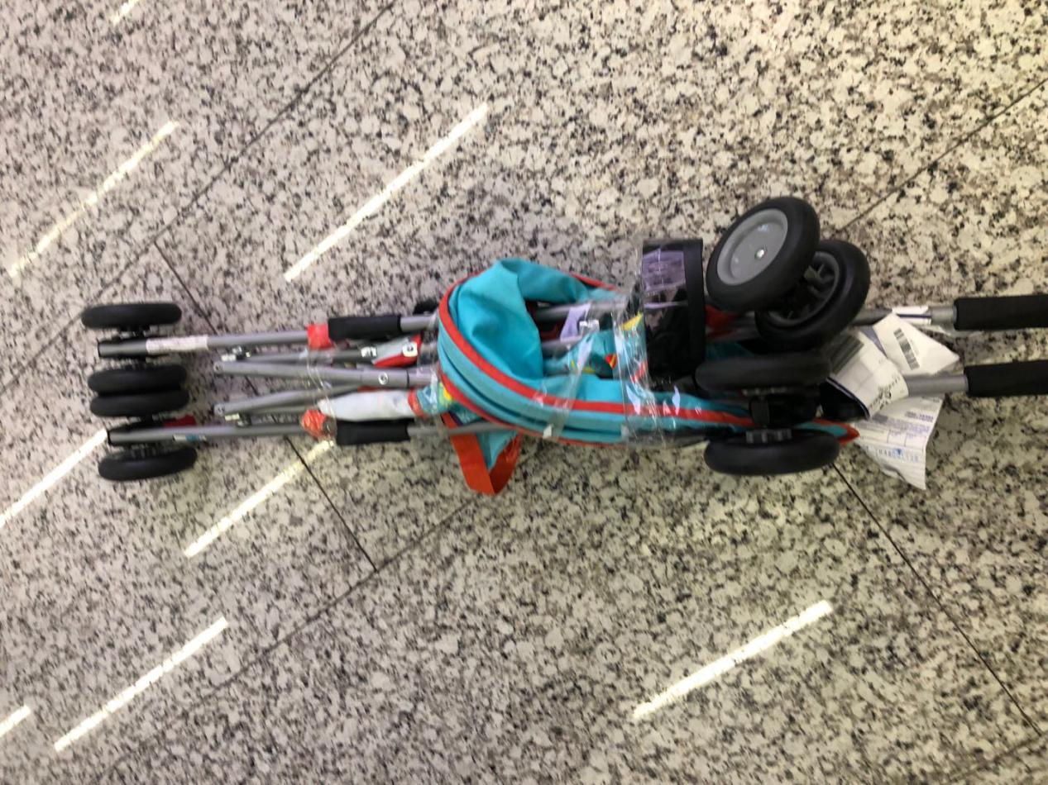
- OHD CANCZ90237 仓号19021456
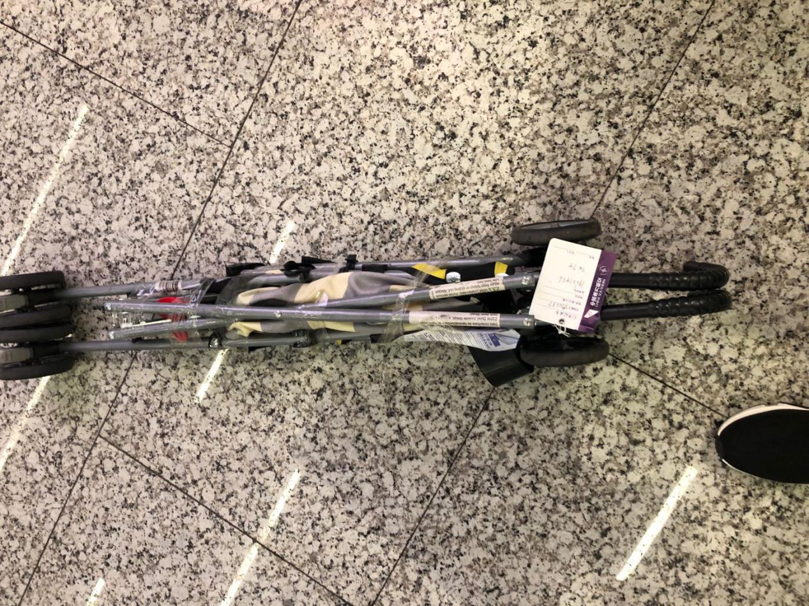
- OHD CANCZ90420 仓号19022630
- OHD CANCZ90273 仓号19021760.
- OHD CANCZ90469仓号19030160
- OHD CANCZ90235 仓号19021453
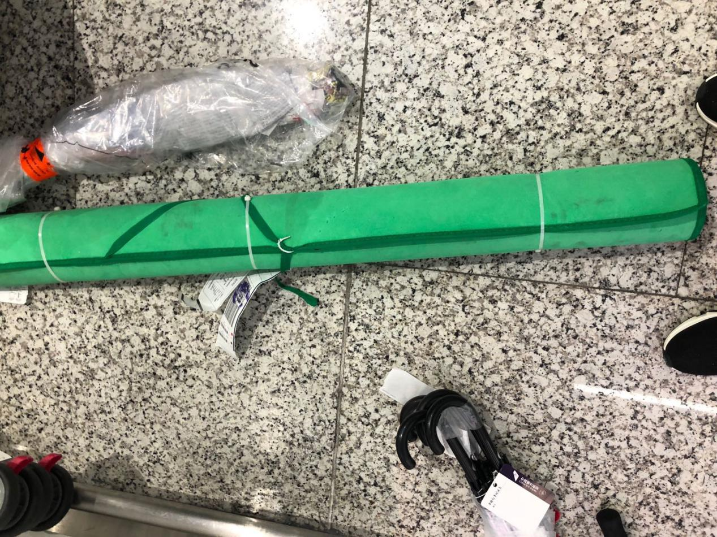
- OHD CANCZ90275 仓号19021761
- OHD CANCZ90380 仓号19022452
- OHD CANCZ90125 仓号19020519
- OHD CANCZ90082 仓号19020151
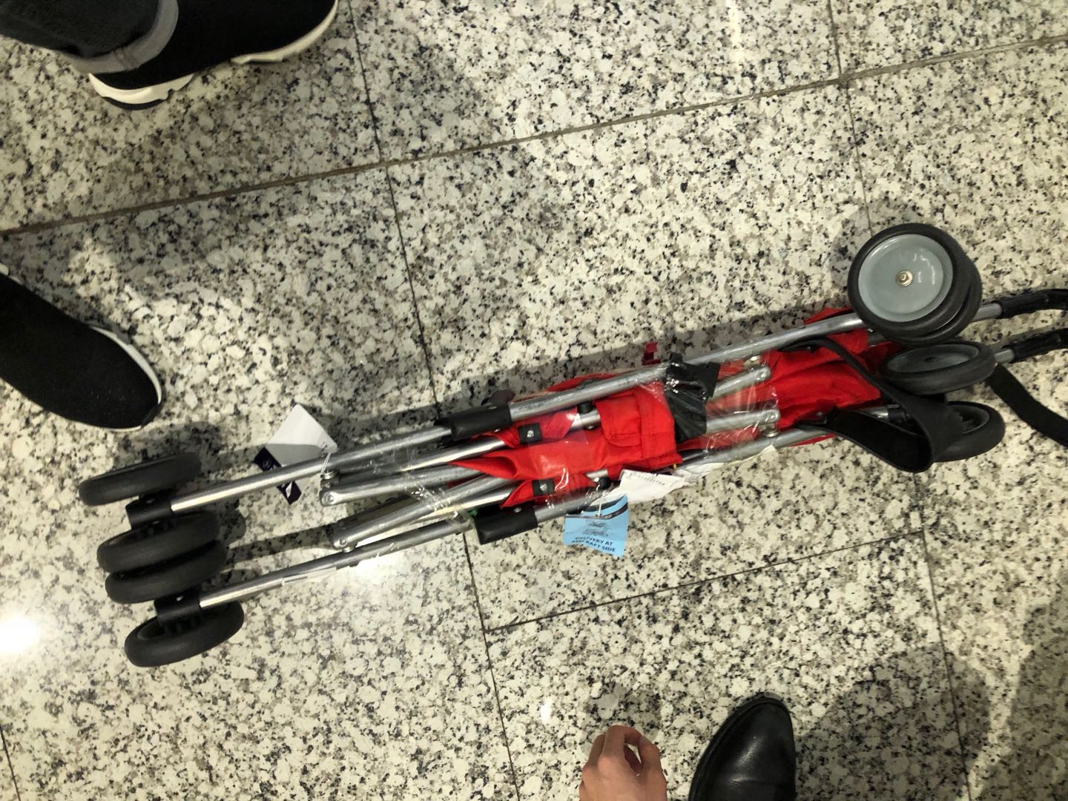
- OHD CANCZ90194 仓号19021208
- OHD CANCZ88768 仓号18113053
- OHD CANCZ90287 仓号19021819
- OHD CANCZ90286 仓号19021818
- OHD CANCZ90347 仓号19022336
- OHD CANCZ90139 仓号19020641
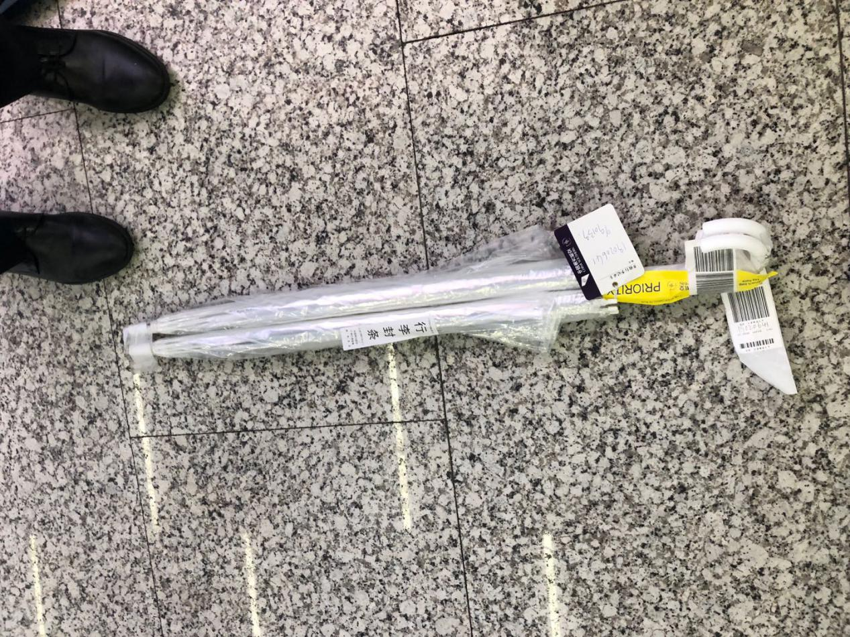
- OHD CANCZ90533 仓号19030417
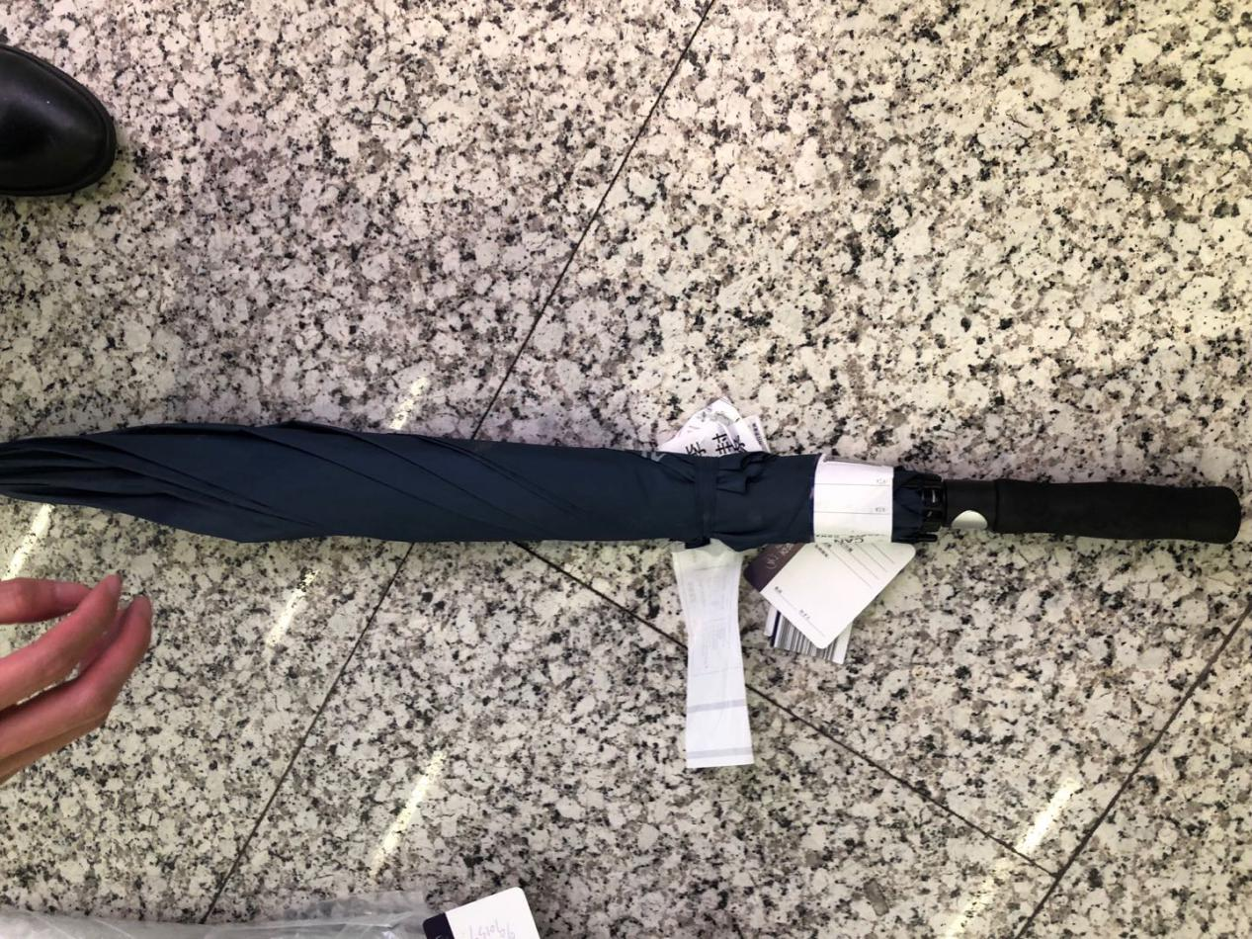
- OHD CANCZ90236 仓号19021455
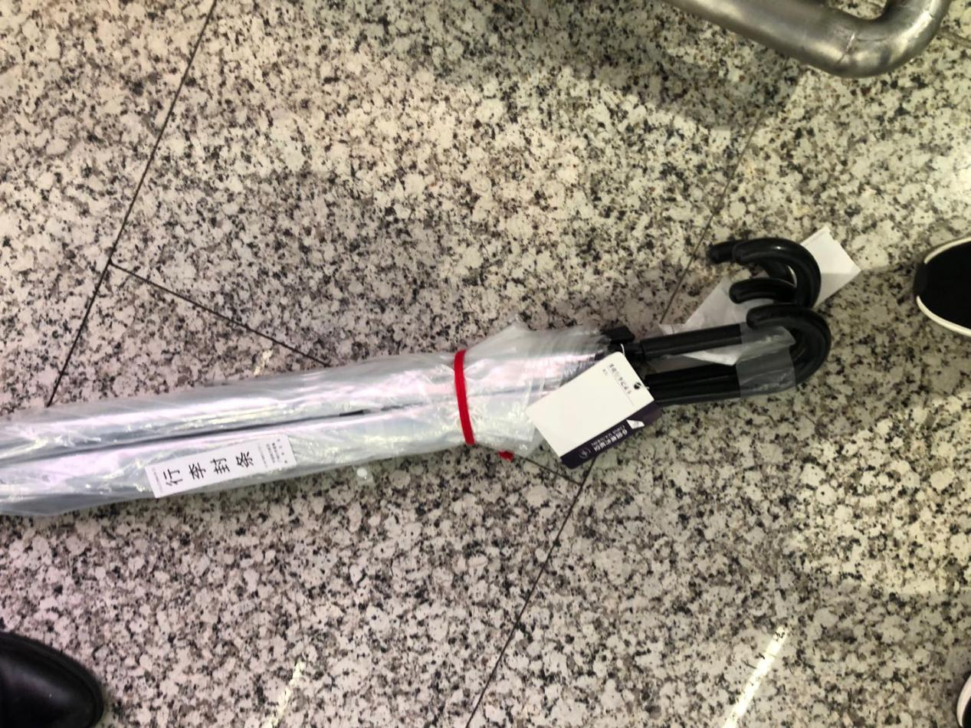
- OHD CANCZ061912
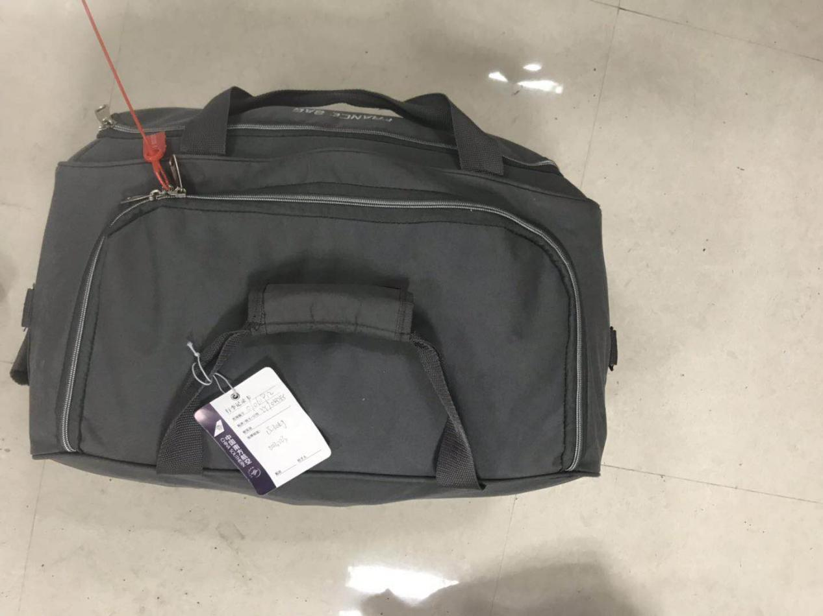
- OHD CANCZ061859
- OHD CANCZ062341 TN CZ809508
- OHD CANCZ89062 TN CZ023972
- OHD CANCZ89246 TN CZ357124
- OHD CANCZ062286 TN CZ735795
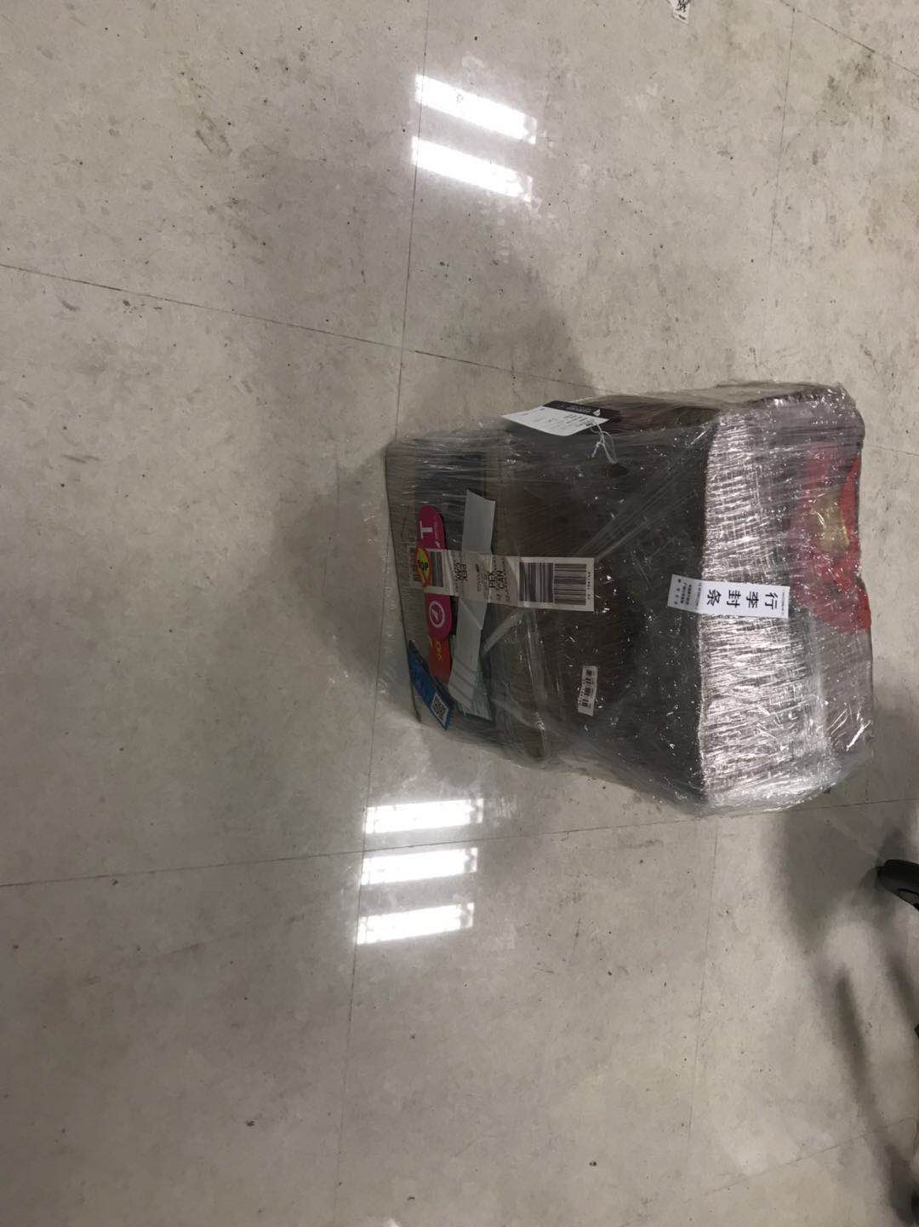
- OHD CANCZ062185
- OHD CANCZ89247 TN CZ747151
