2019年6月6日共处理逾期行李75件，

保管箱号NO.8005/8033两个集装箱内
- OHD CANCZ90383 仓号19022456
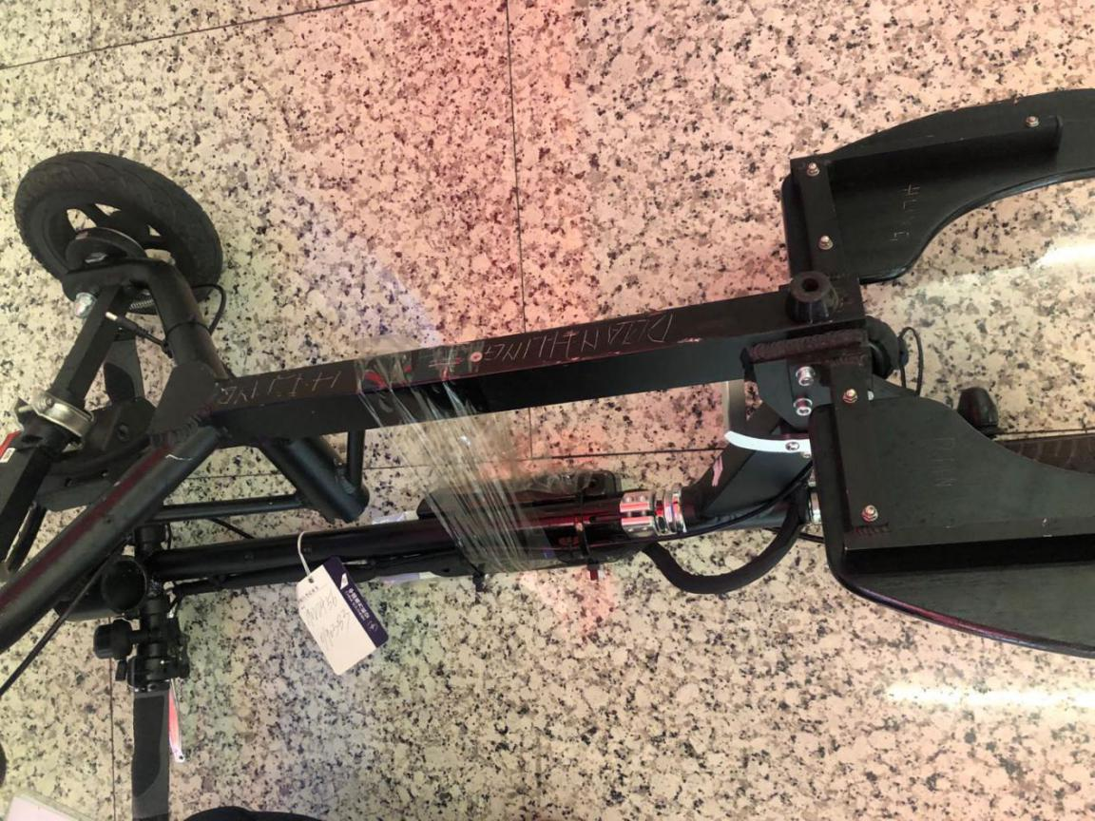
- OHD CANCZ91002 仓号19040731
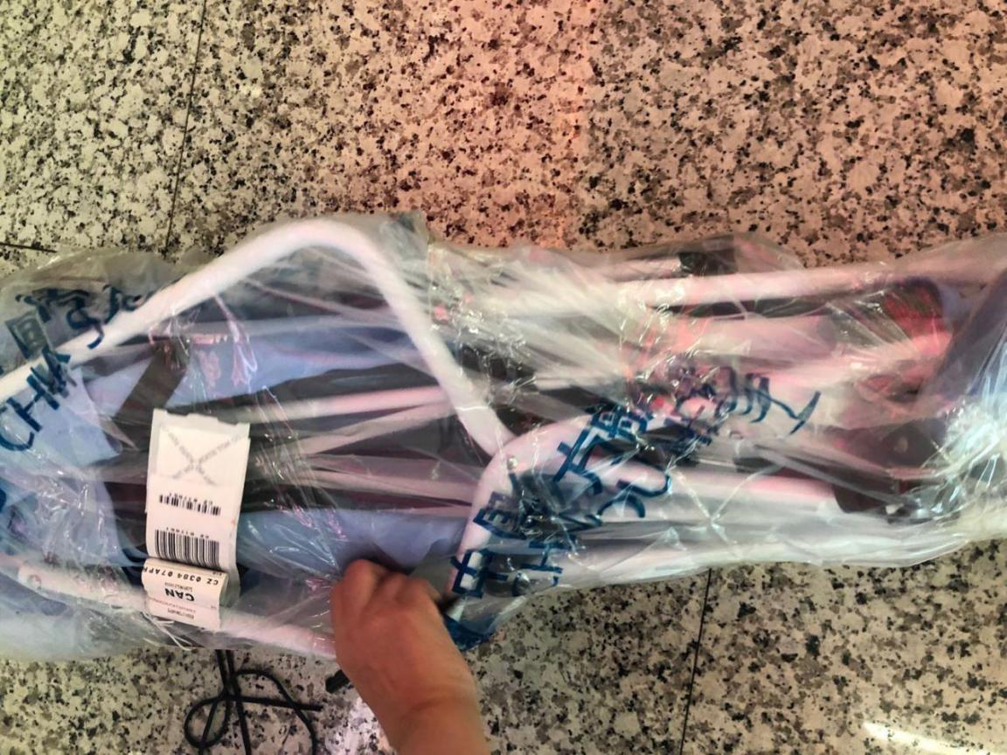
- OHD CANCZ90218 仓号19021355
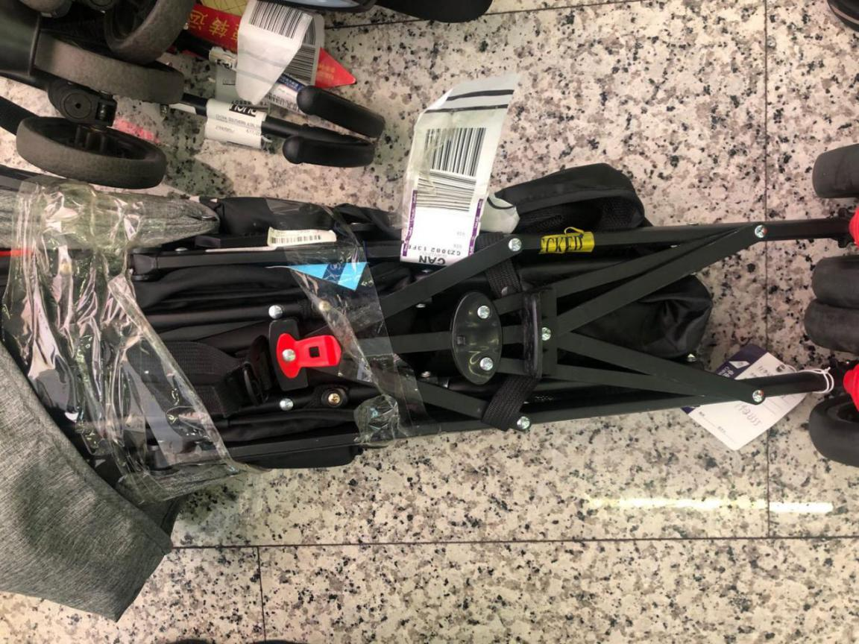
- OHD CANCZ91067 仓号19041212
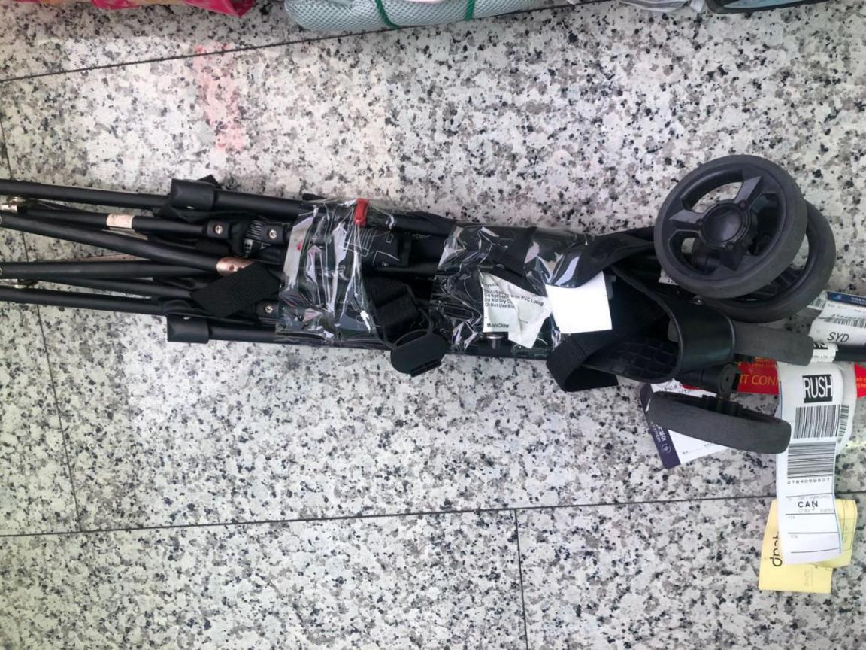
- OHD CANCZ91468 仓号19050643
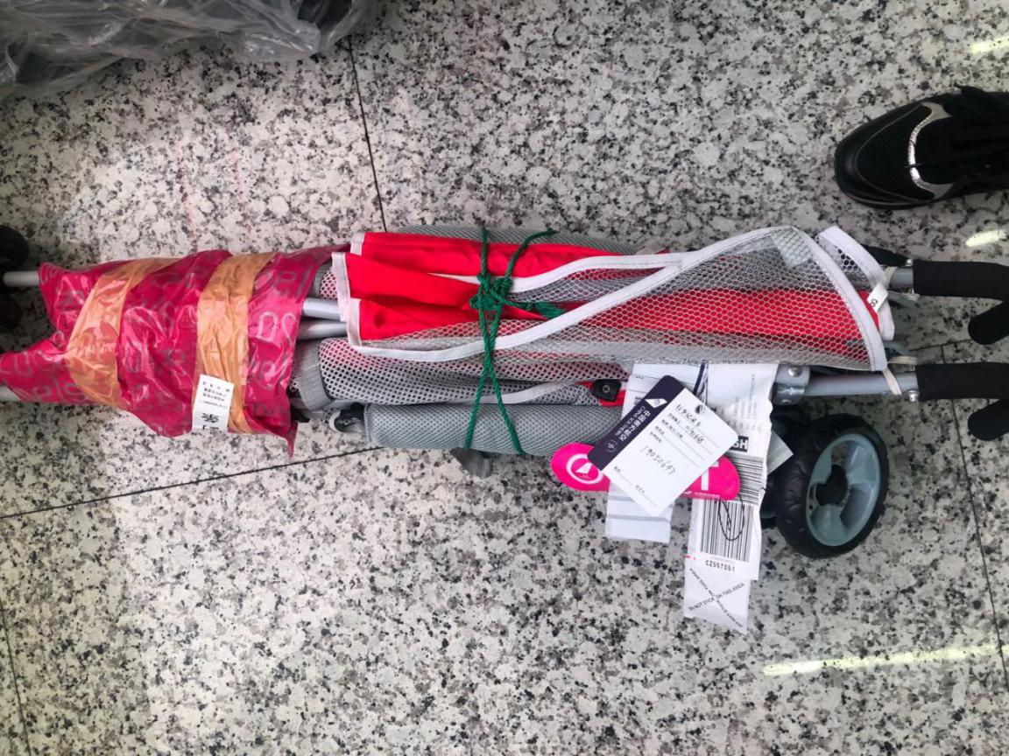
- OHD CANCZ91444 仓号19050421
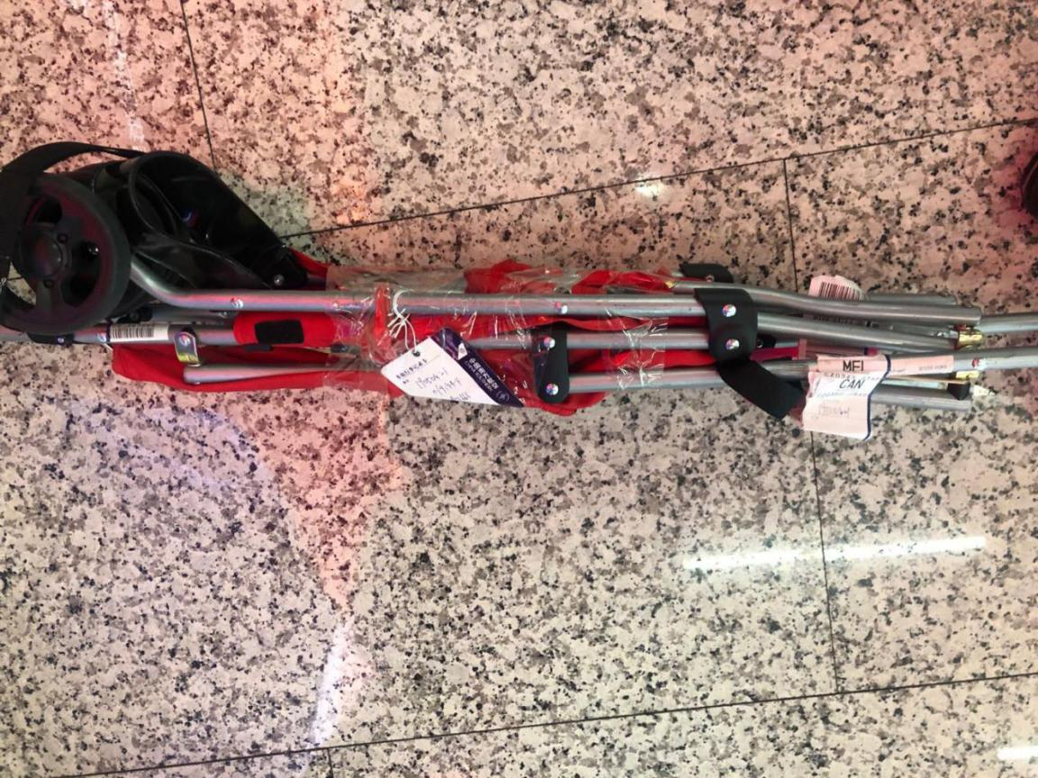
- OHD CANCZ90933 仓号19040215
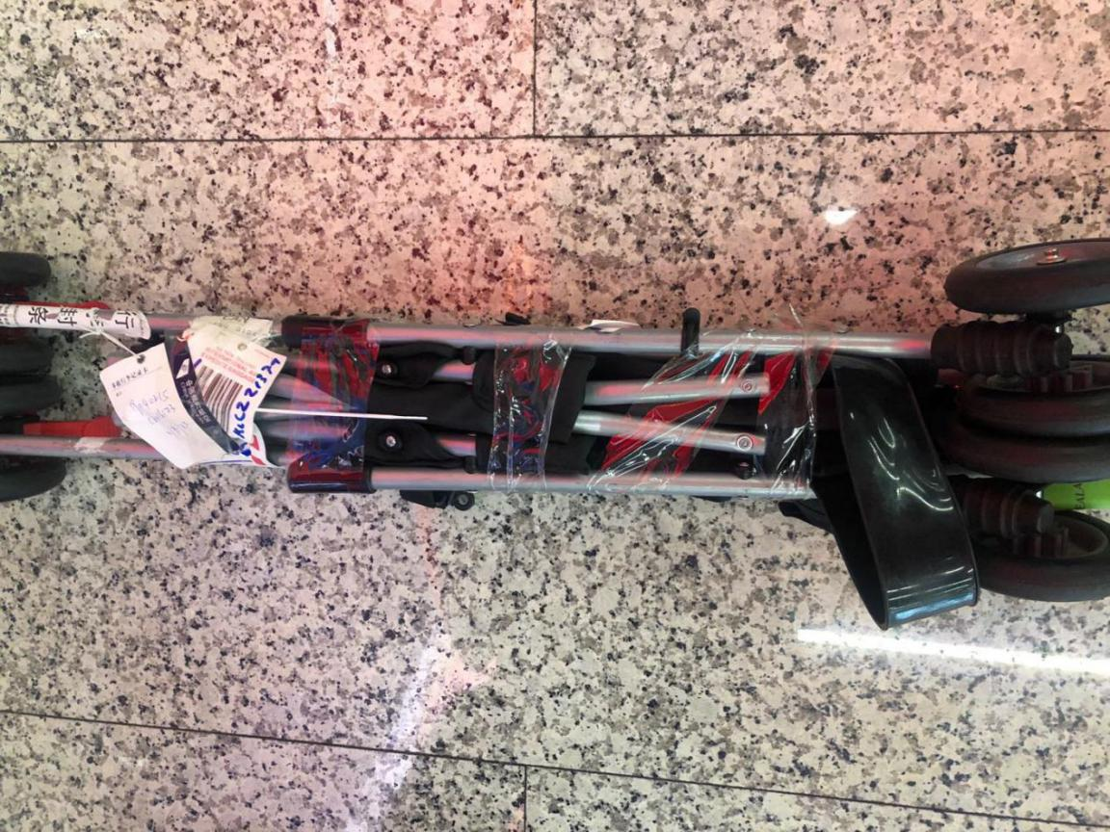
- OHD CANCZ91275 仓号19042410
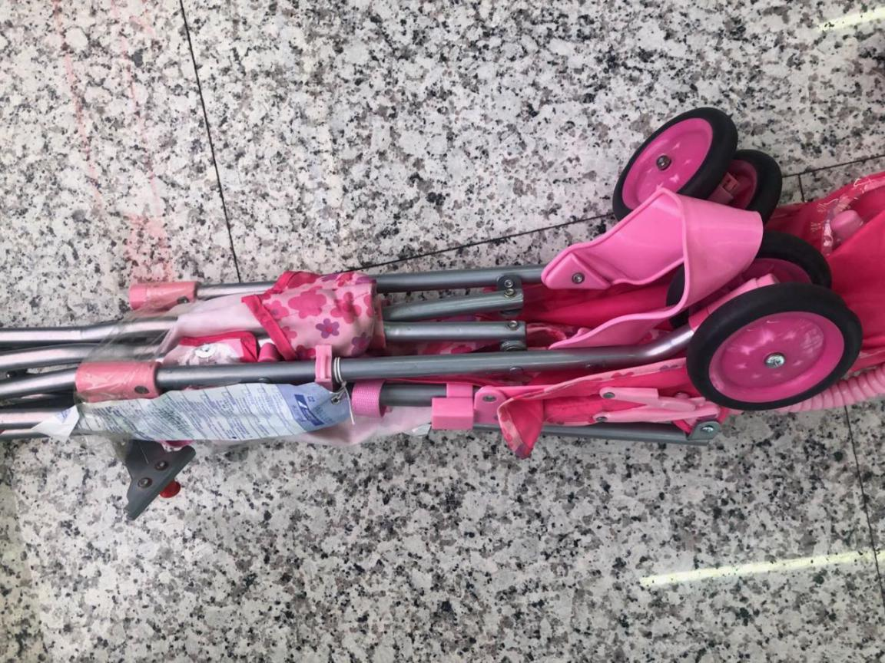
- OHD CANCZ90782 仓号19032112
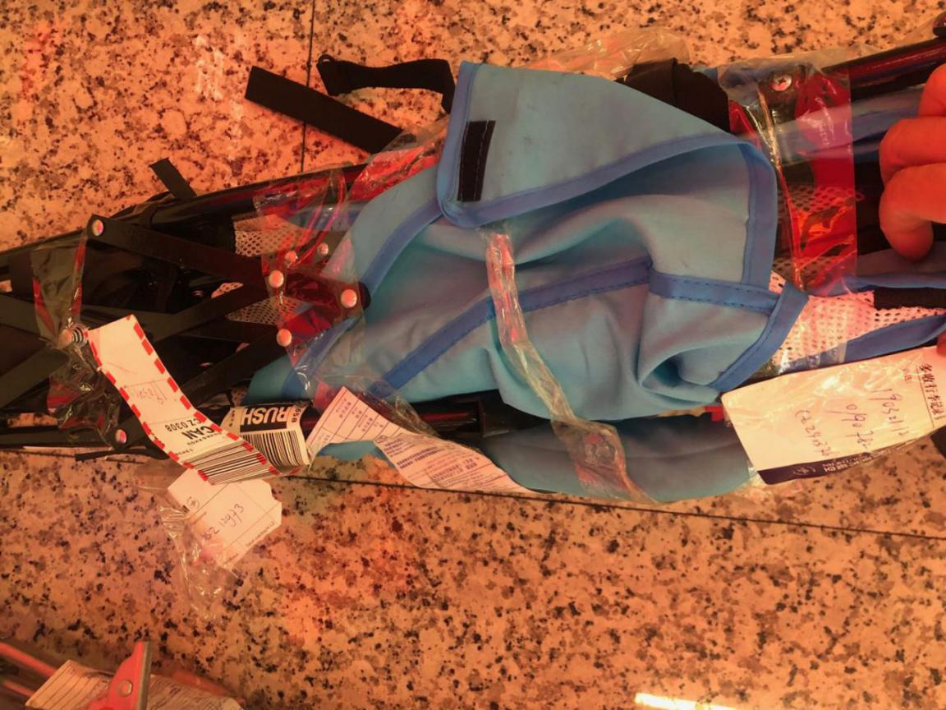
- OHD CANCZ90688 仓号19031467
- OHD CANCZ91385 仓号19042961
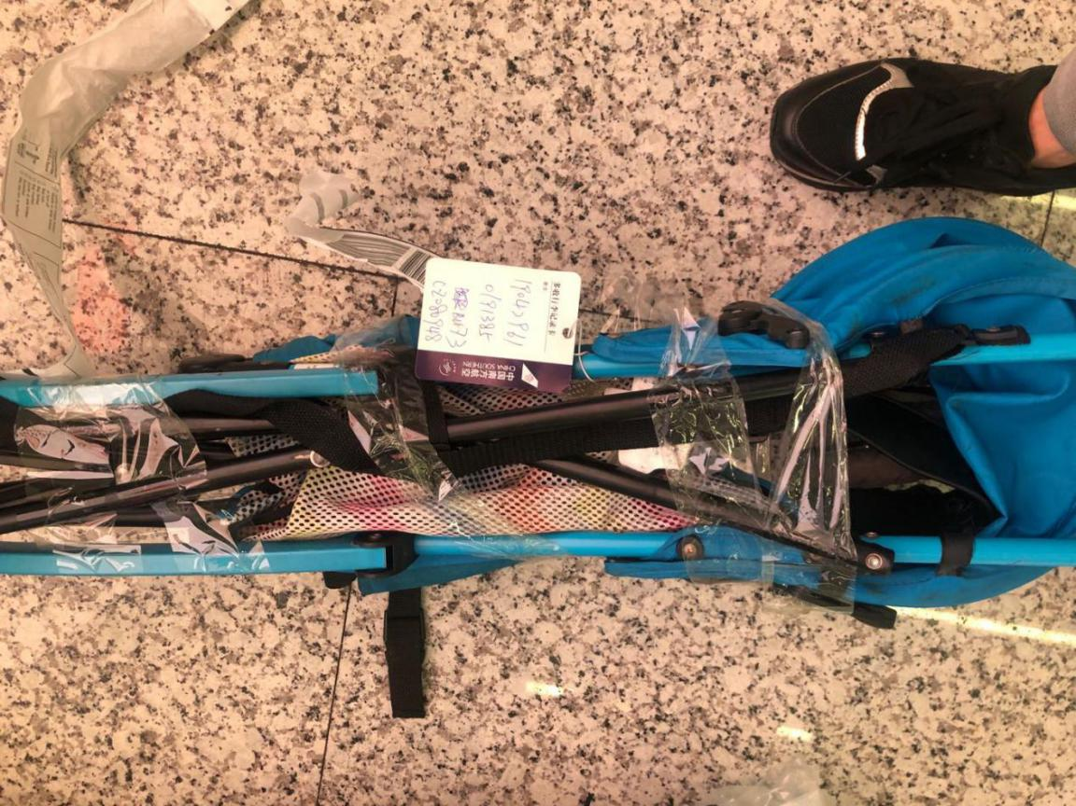
- OHD CANCZ90857 仓号19032749
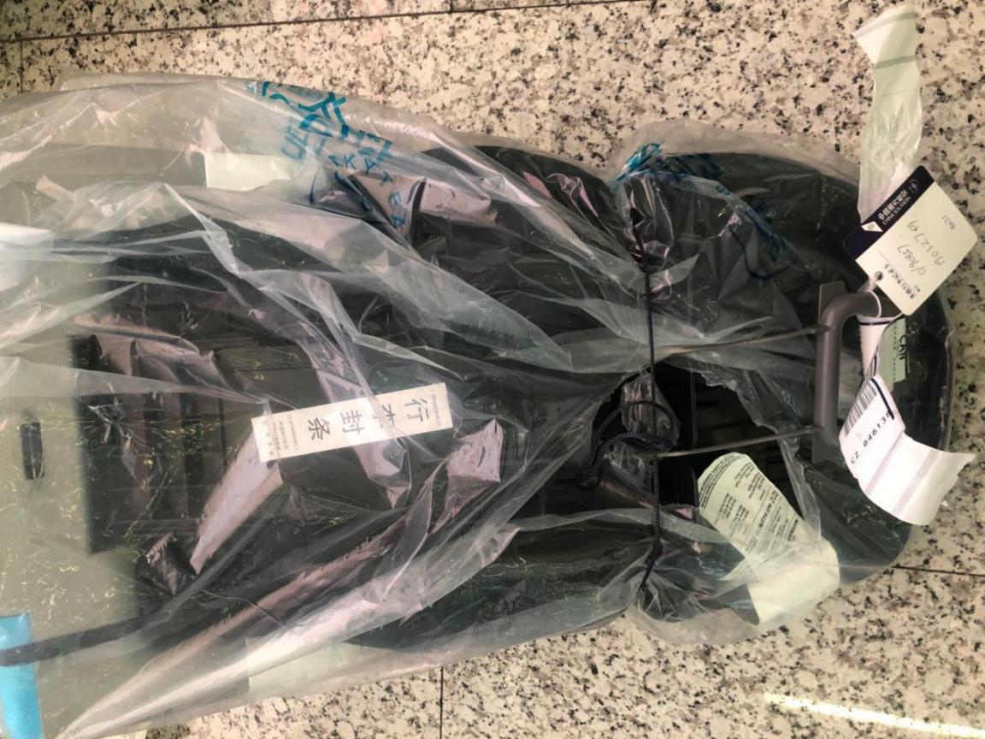
- OHD CANCZ90796 仓号19032257
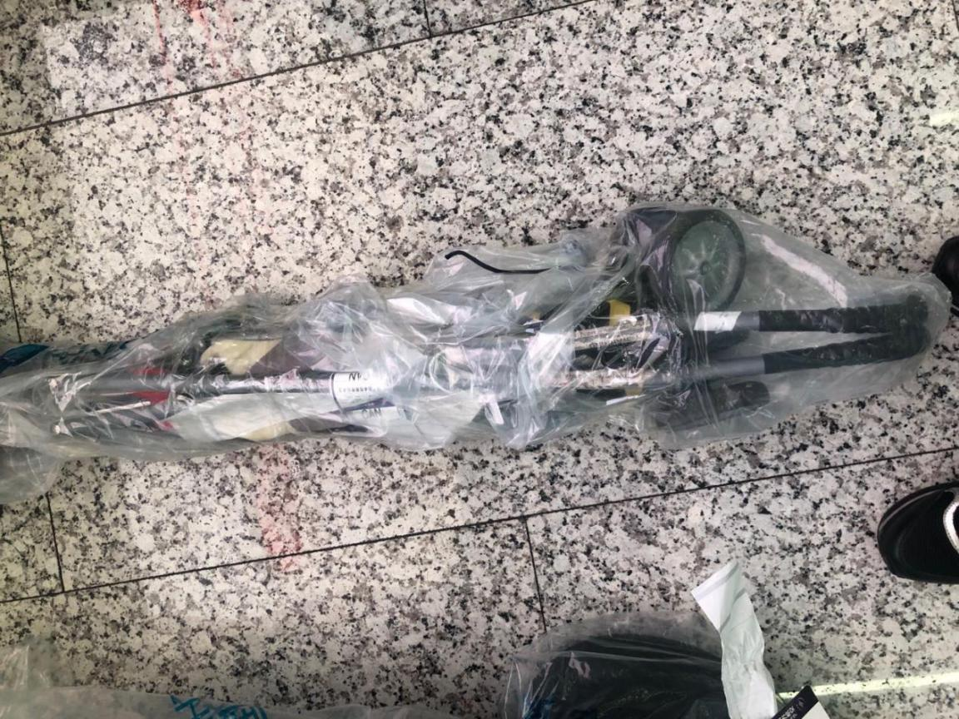
- OHD CANCZ90674 仓号19031311
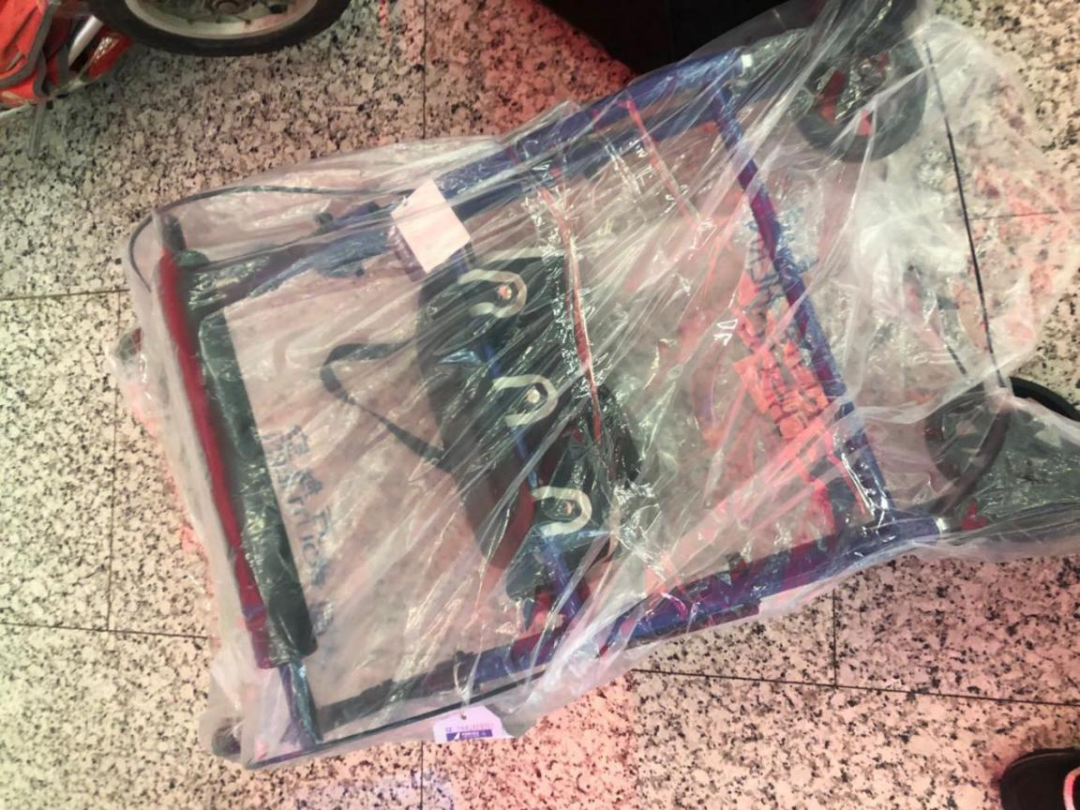
- OHD CANCZ91177 仓号19041853
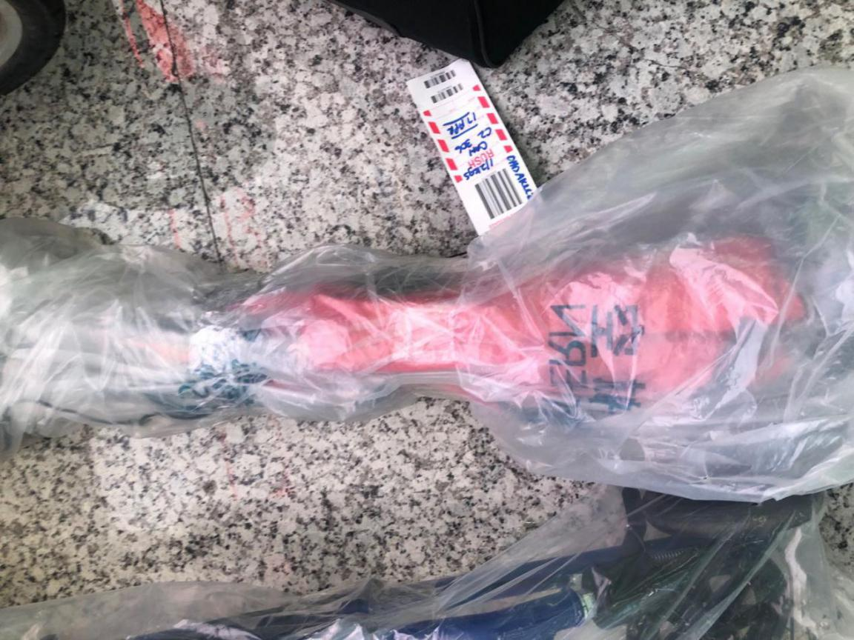
- OHD CANCZ90382 仓号19022455
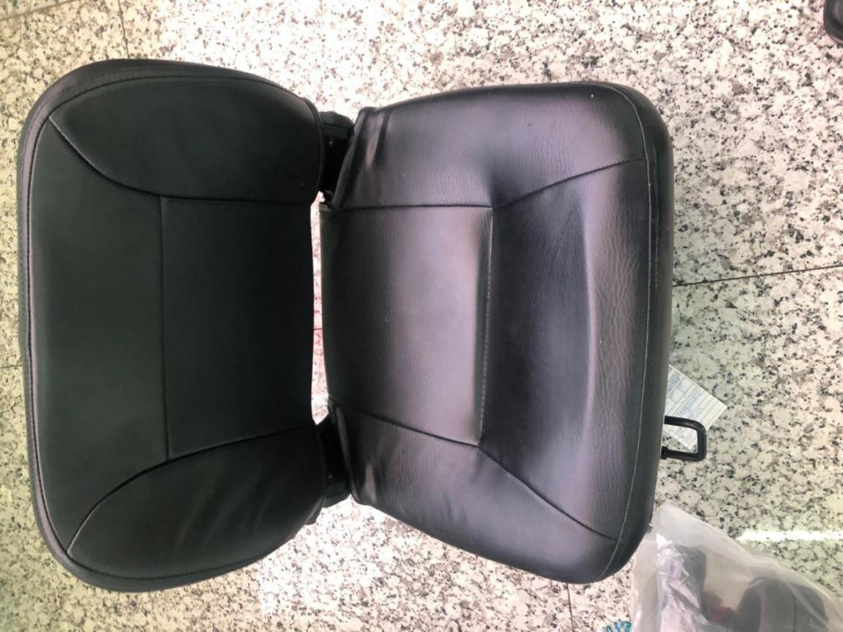
- OHD CANCZ91321仓号19042772
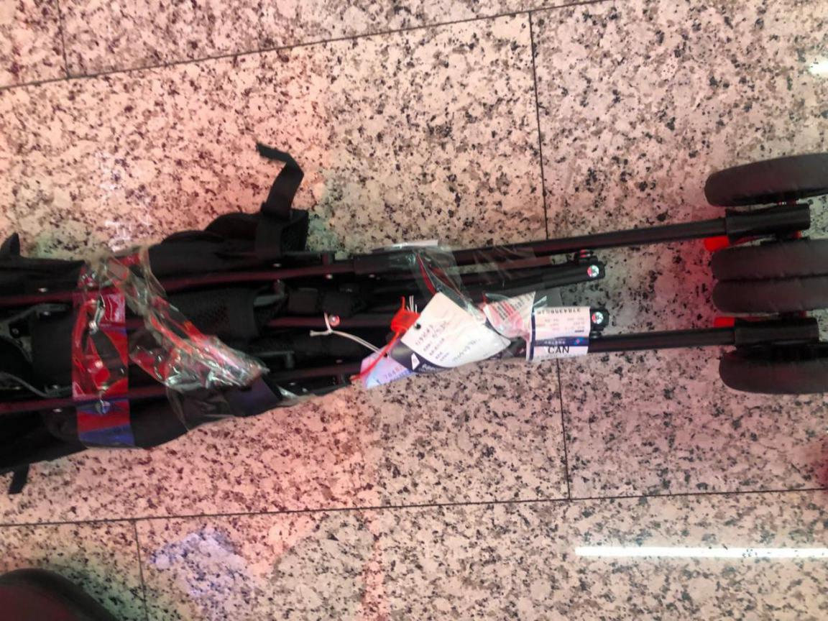
- OHD CANCZ91030 仓号19041031
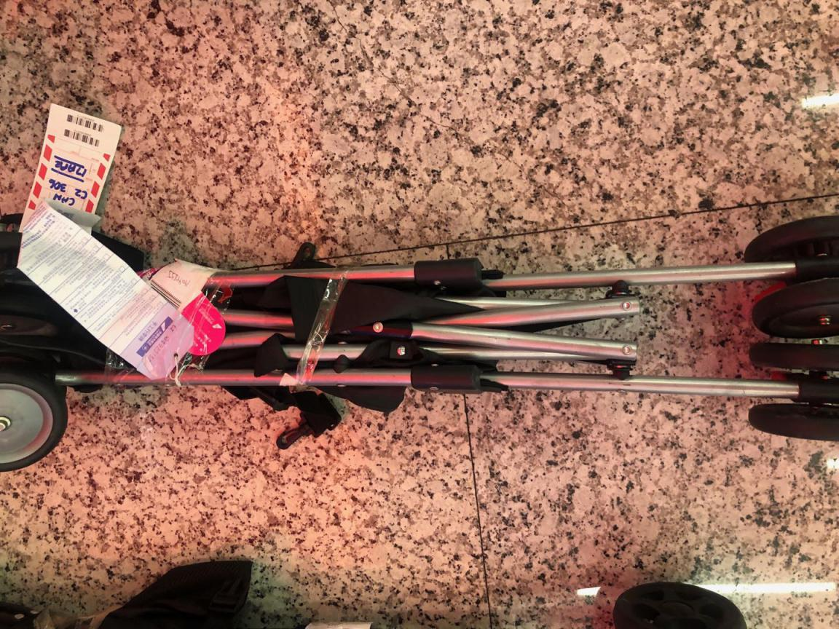
- OHD CANCZ91030 仓号19041031
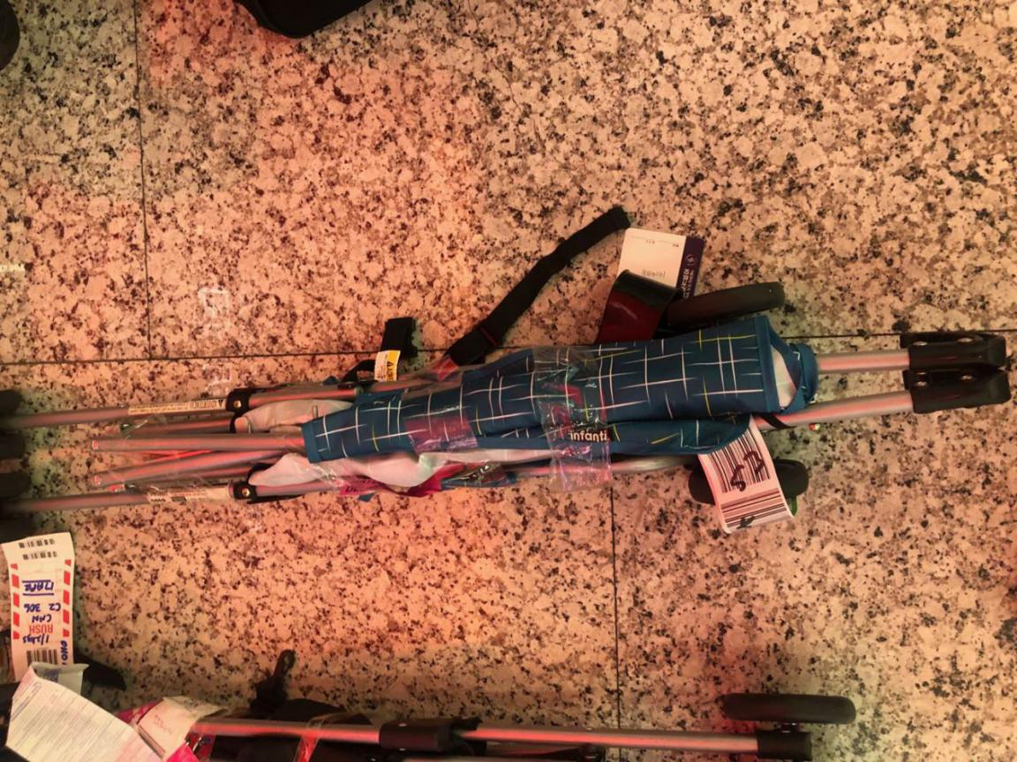
- OHD CANCZ91178 仓号19041854
- OHD CANCZ90955仓号19040313
- OHD CANCZ90818 仓号19032337
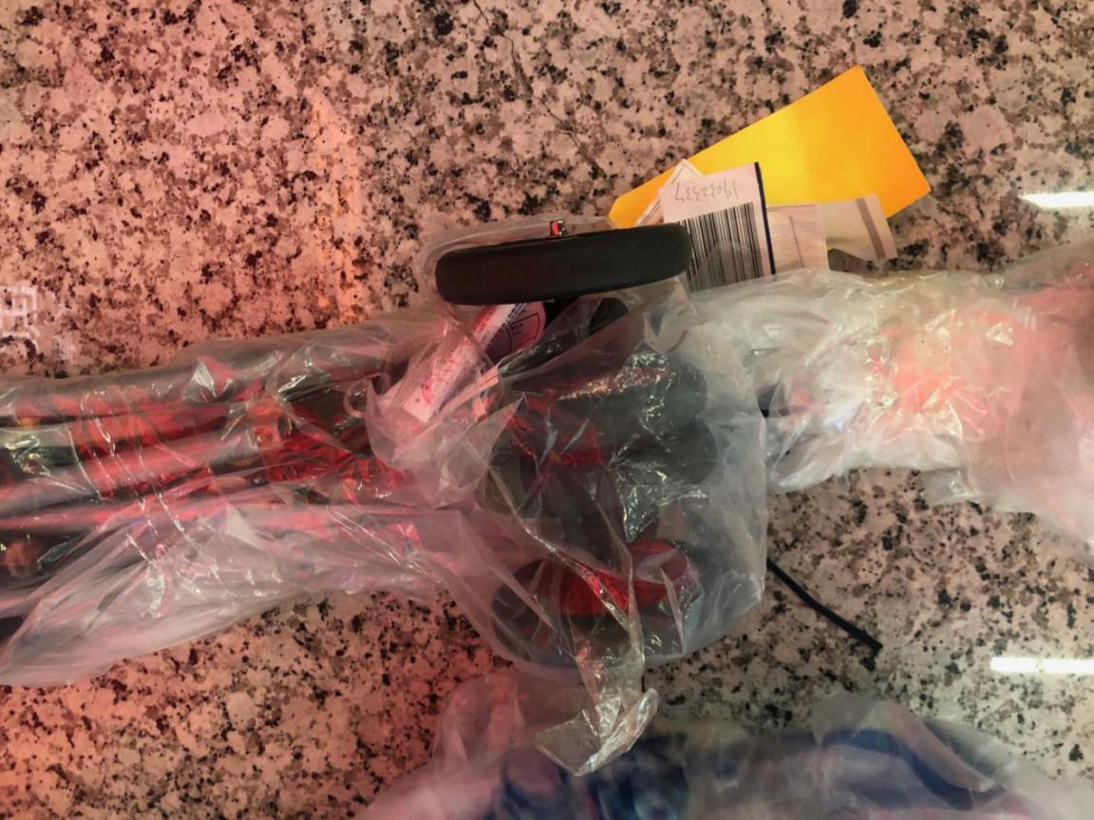
- OHD CANCZ91137仓号190415100
- OHD CANCZ90492 仓号19030266
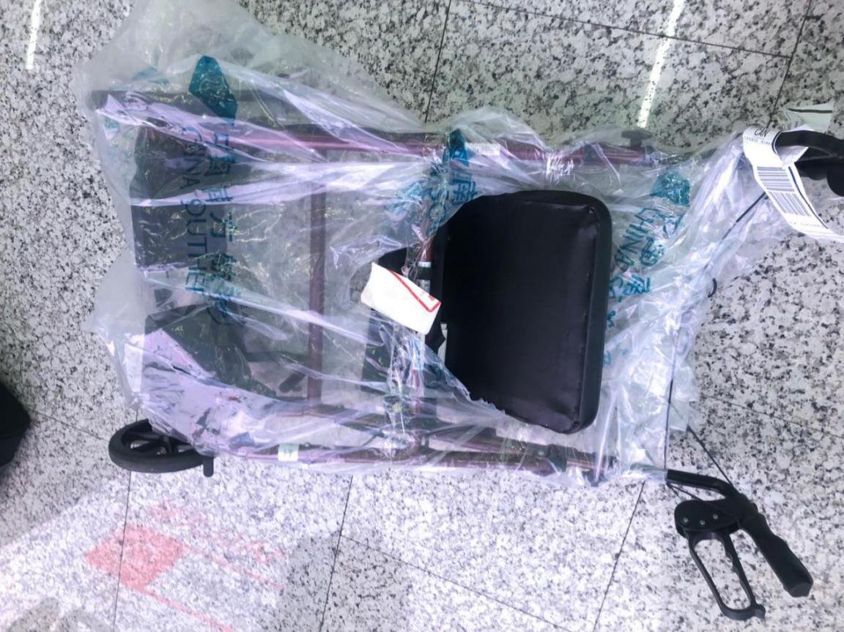
- OHD CANCZ91035 仓号19041070
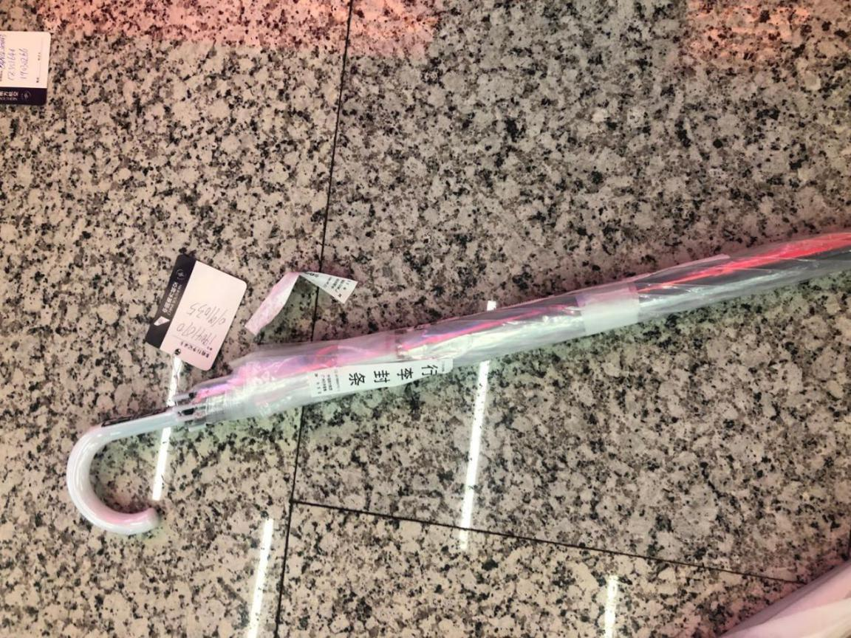
- OHD CANCZ91034 仓号19041069
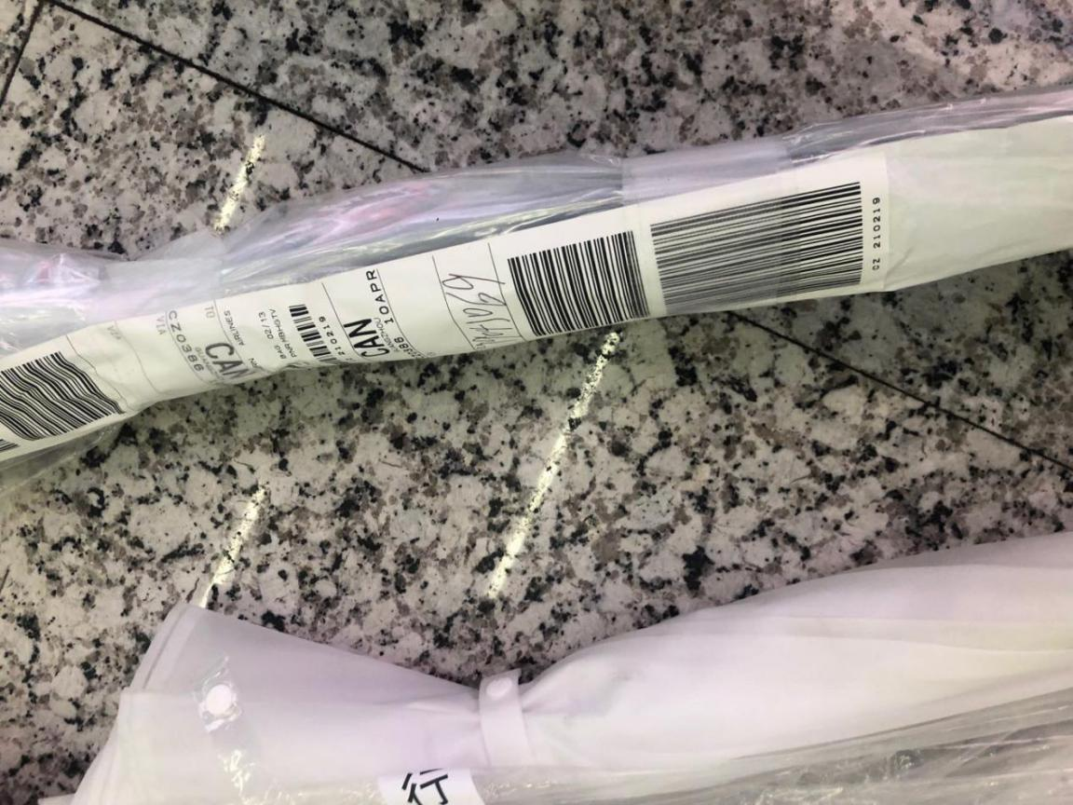
- OHD CANCZ91136 仓号19011487
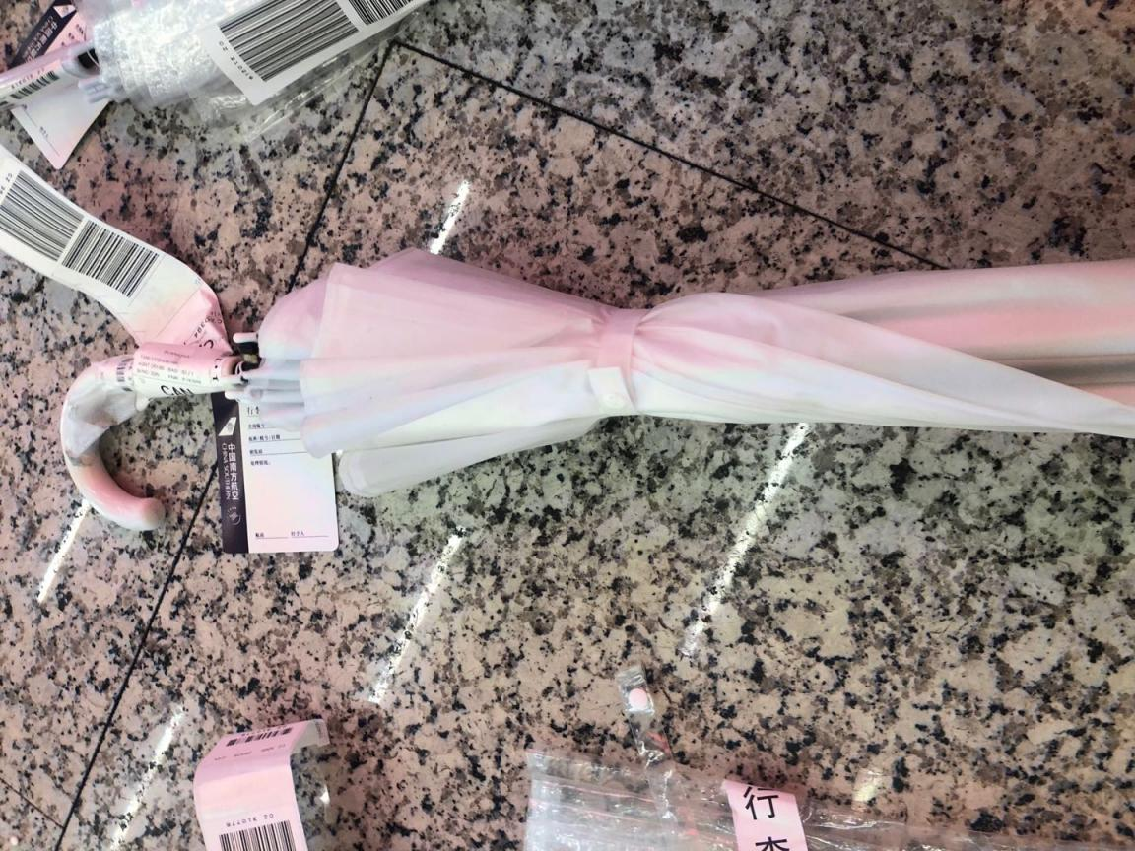
- OHD CANCZ91011 仓号19040854
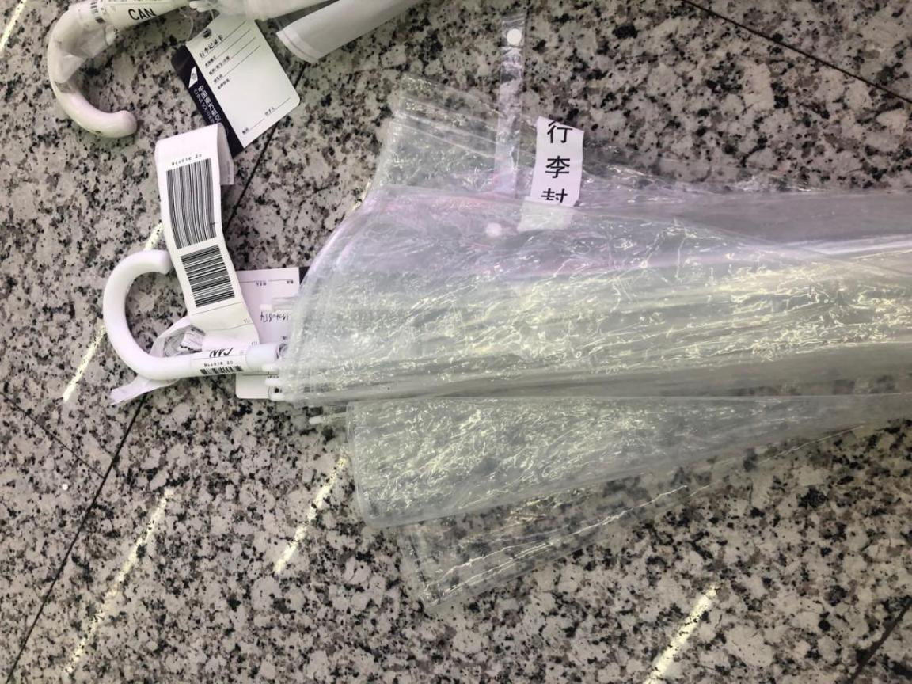
- OHD CANCZ91168 仓号19041740
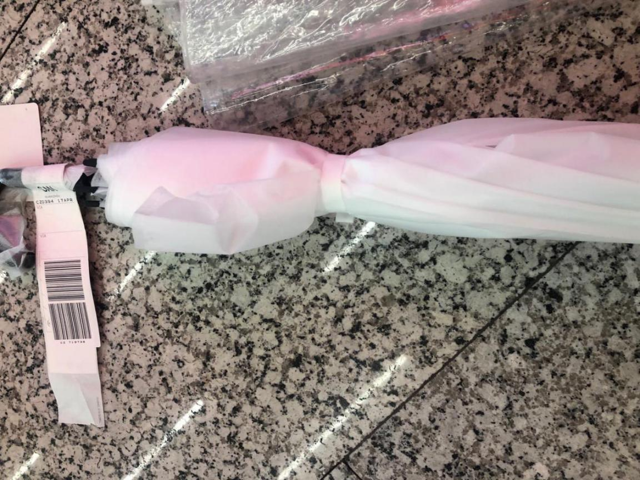
- OHD CANCZ90743仓号19031854
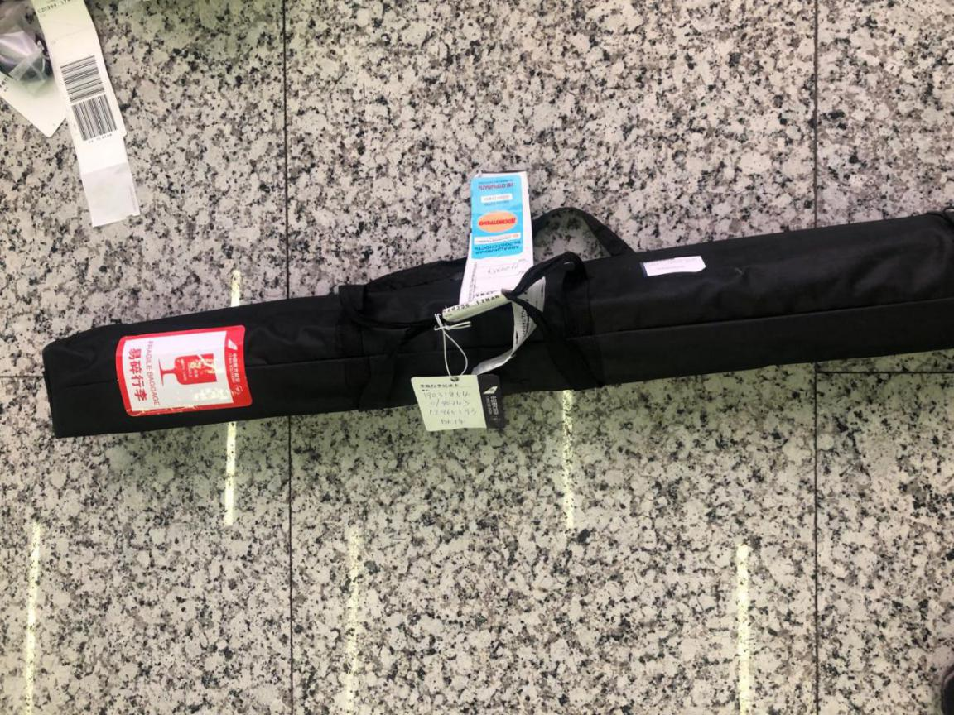
- OHD CANCZ91029 仓号19041032
- OHD CANCZ91647 仓号19051945
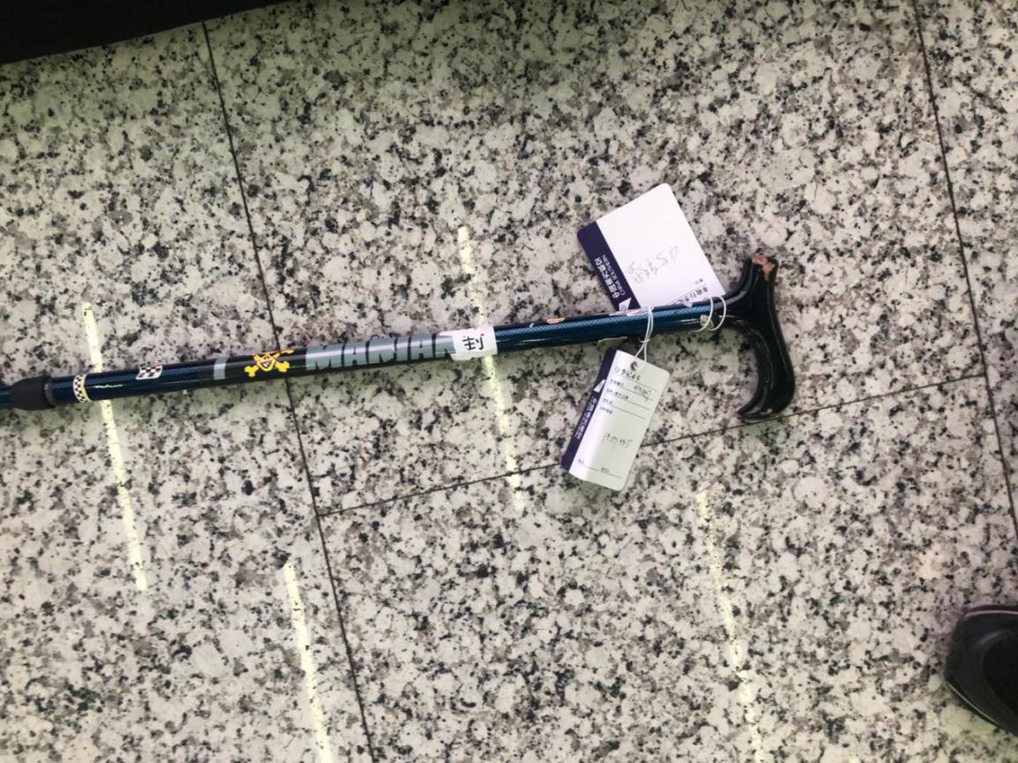
- OHD CANCZ90675 仓号19031330
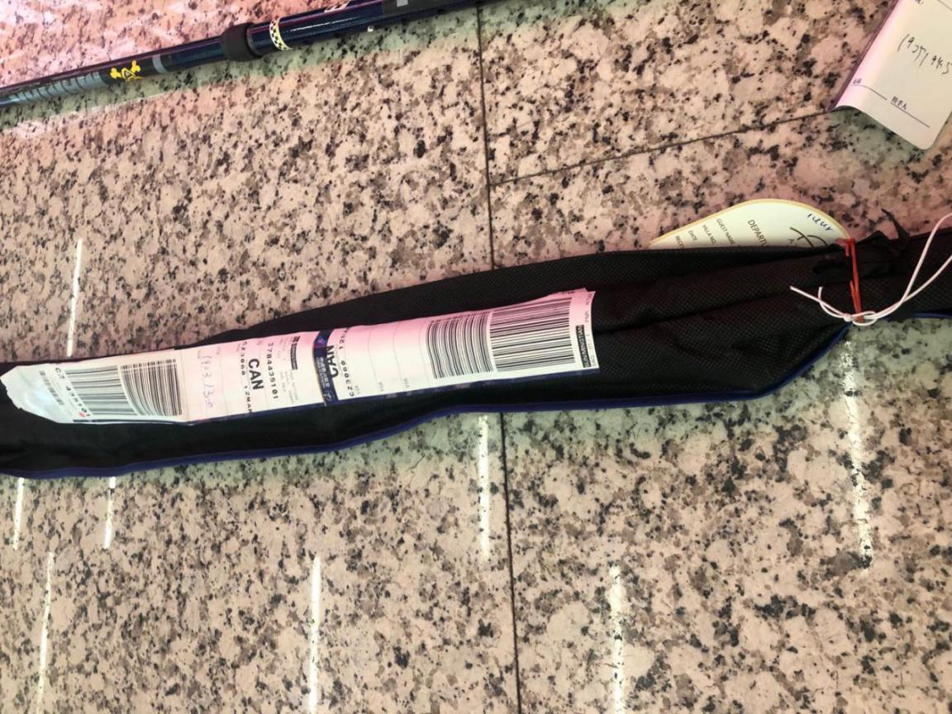
- OHD CANCZ90904 仓号19033049
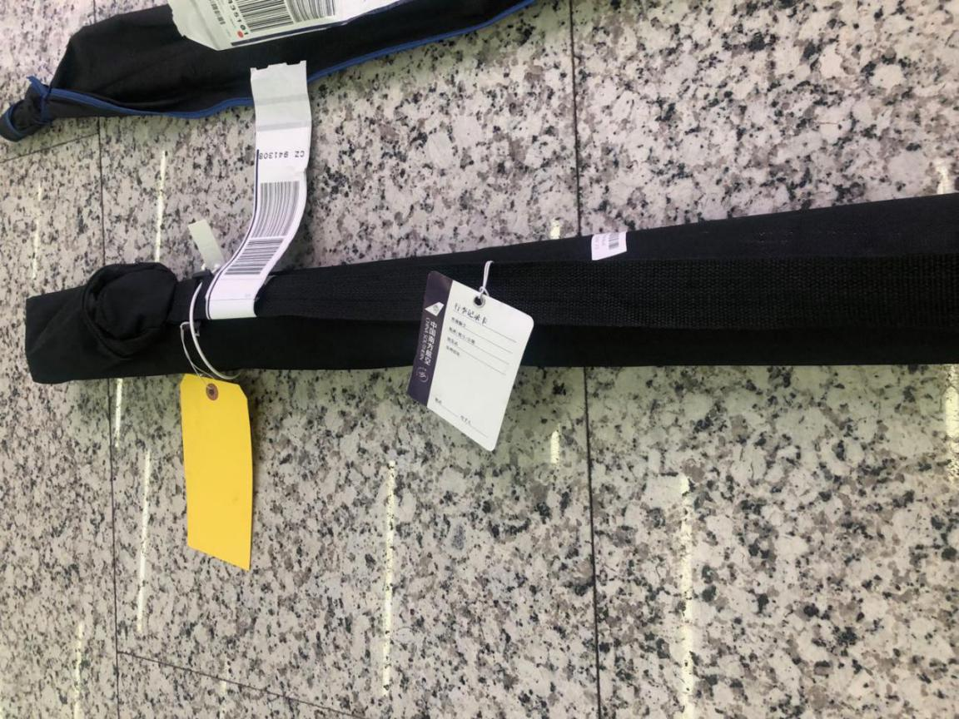
- OHD CANCZ90753 仓号19031921
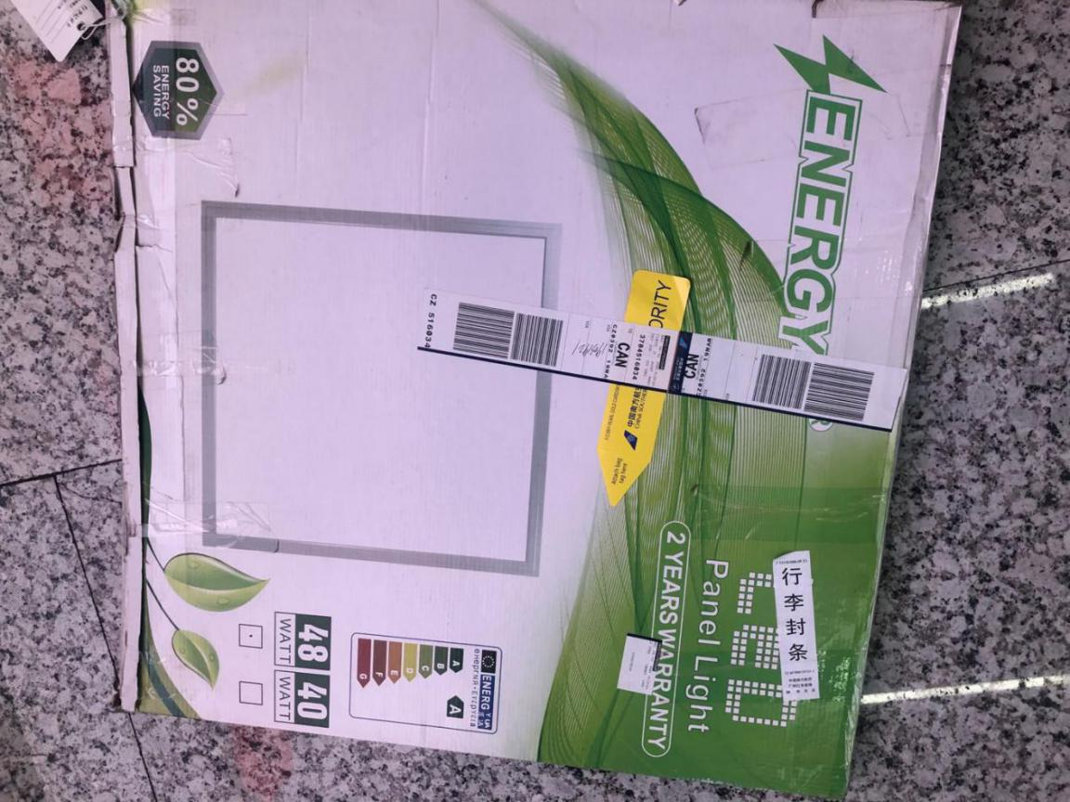
- OHD CANCZ91731 仓号19052434
- OHD CANCZ90850 仓号19032618
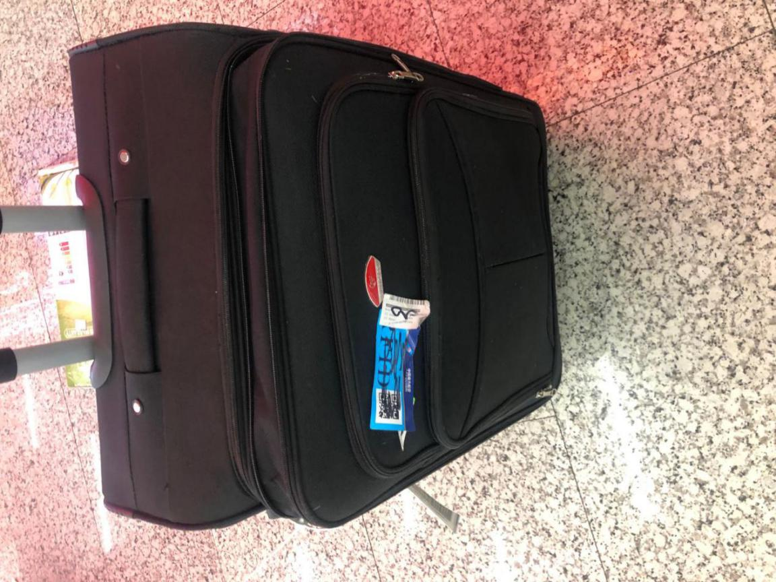
- 仓号19021711
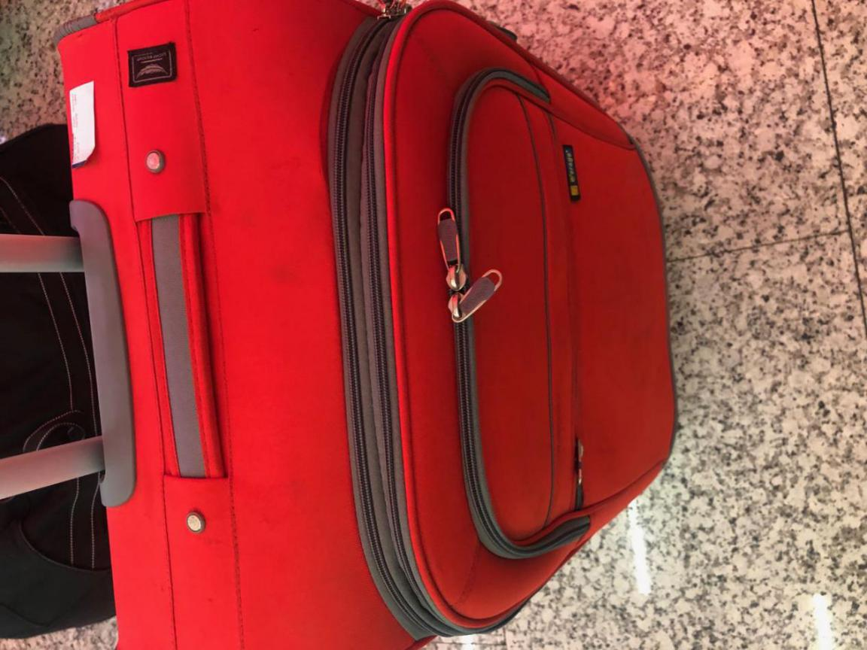
- OHD CANCZ90783 仓号19032157
- OHD CANCZ89535 仓号19010485
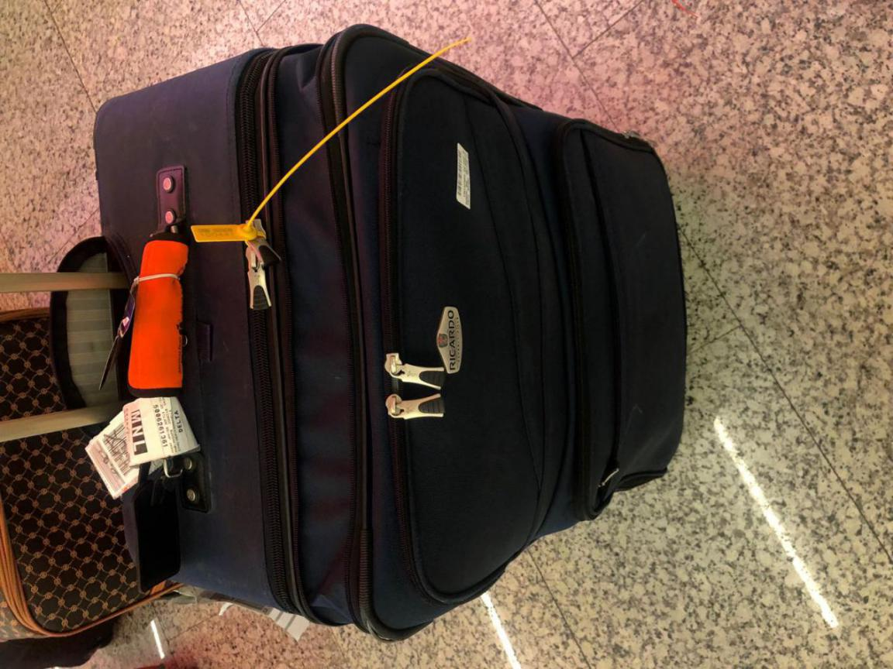
- OHD CANCZ90608仓号19030745
- OHD CANCZ90849 仓号19032616
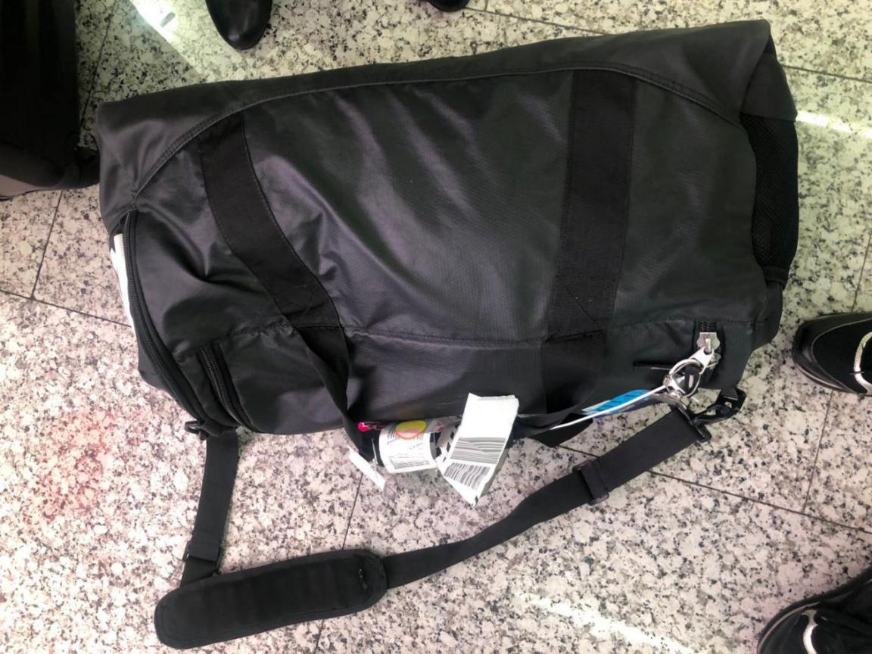
- OHD CANCZ90819仓号19032339
- OHD CANCZ90450 仓号19022891
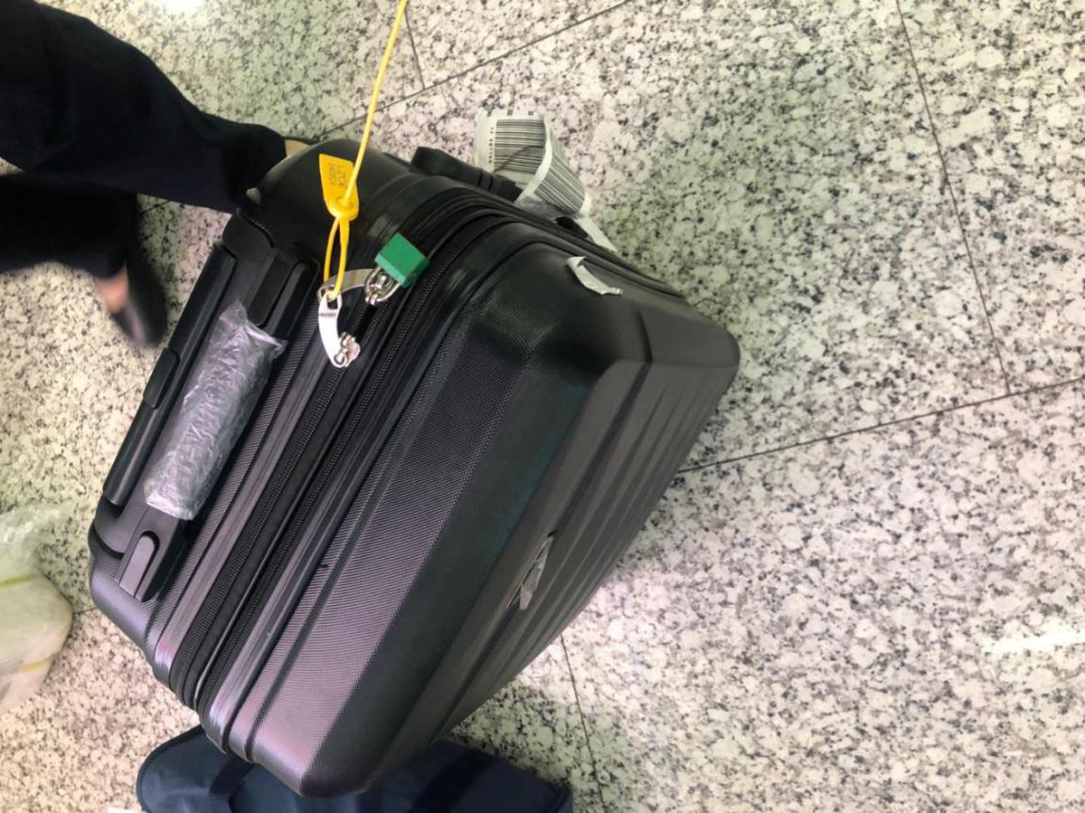
- OHD CANCZ90967 仓号19040458
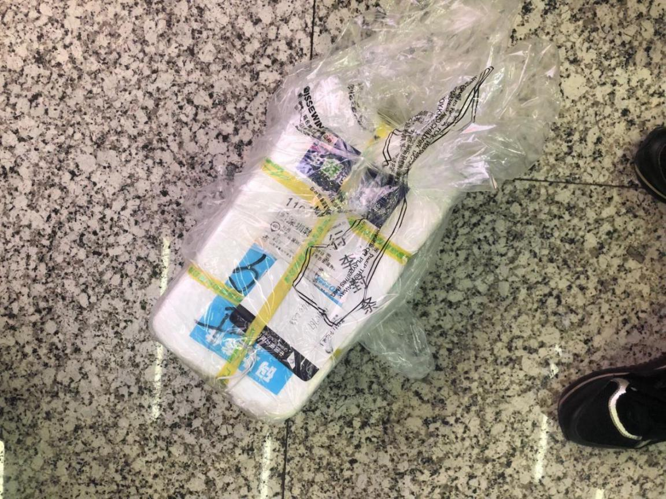
- OHD CANCZ90470 仓号19030161
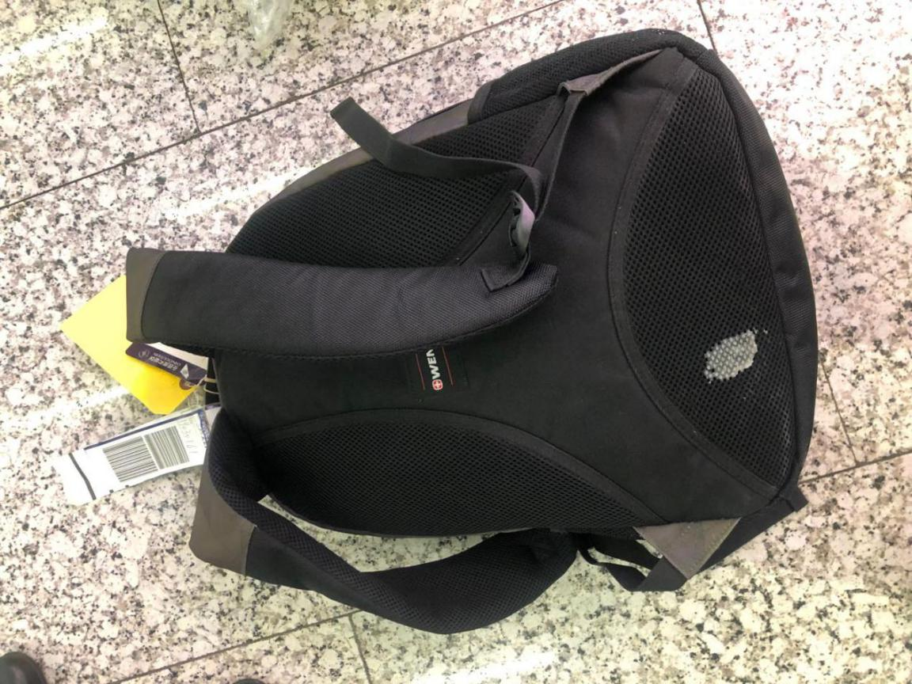
- OHD CANCZ90375 仓号19022415
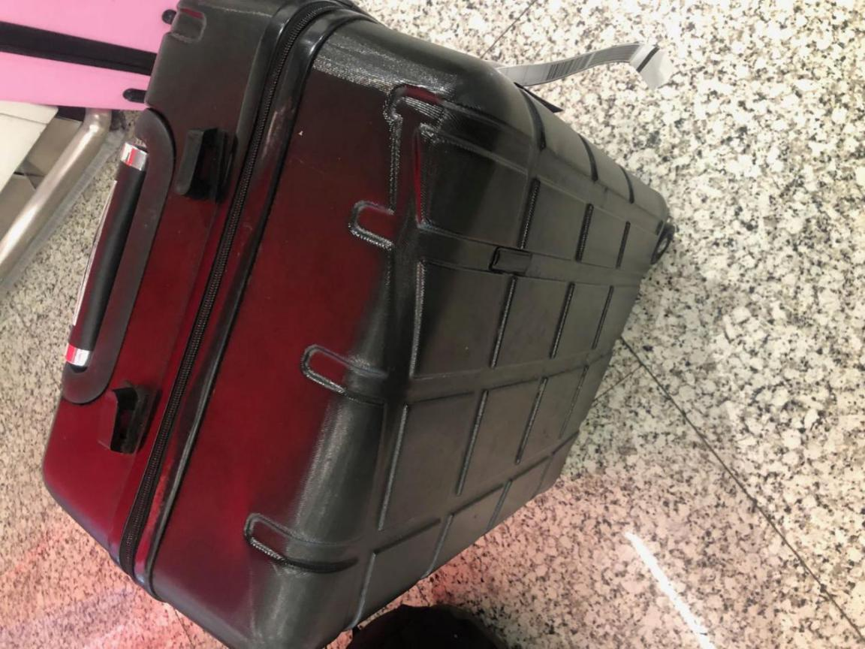
- OHD CANCZ90851 仓号19032644
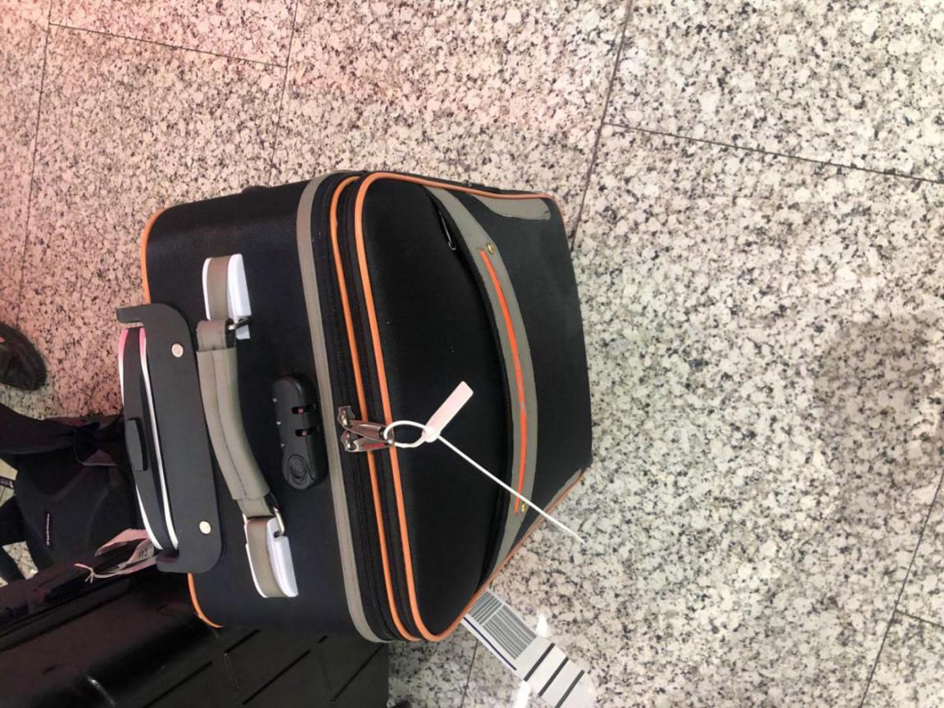
- OHD CANCZ90873 仓号19032861
- OHD CANCZ90358 仓号19022358
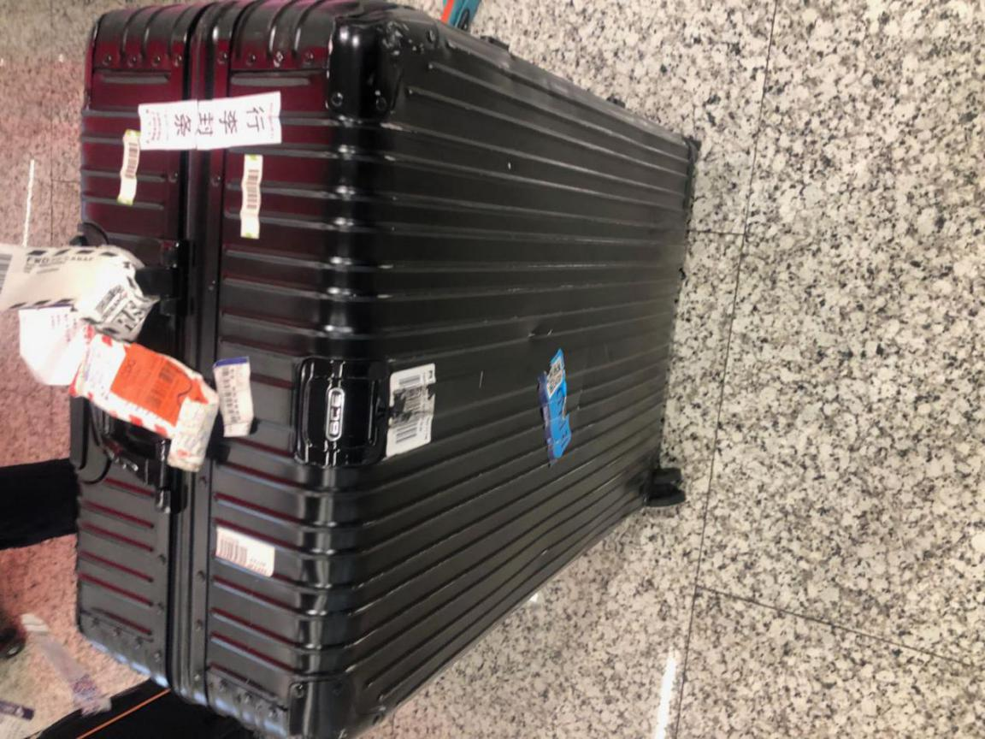
- OHD CANCZ90704 仓号19031599
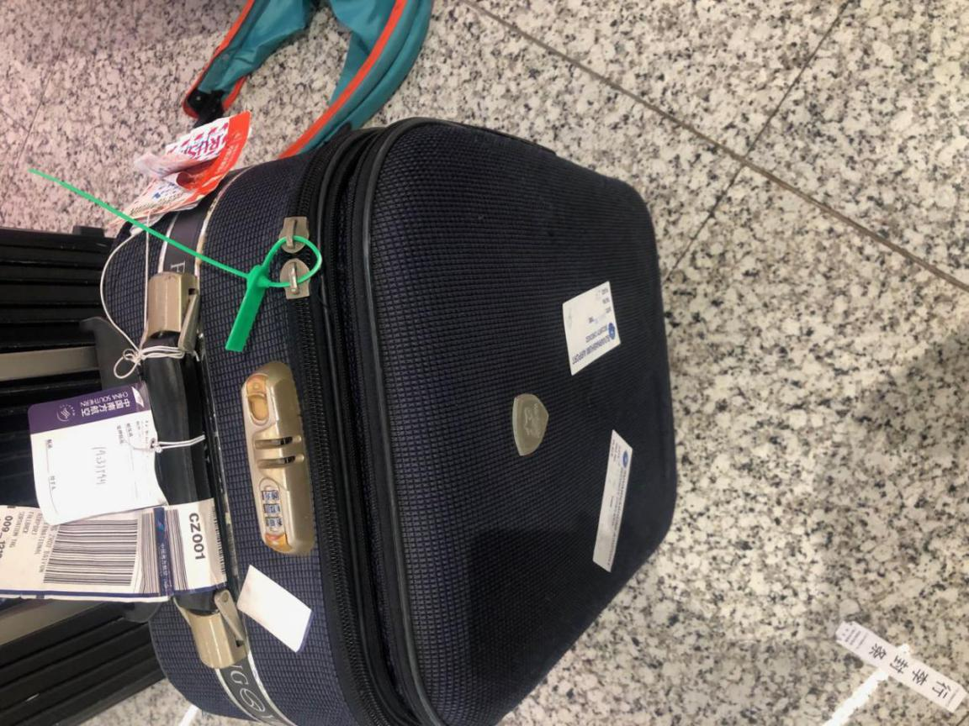
- OHD CANCZ063016 TN CZ523383
- OHD CANCZ061925
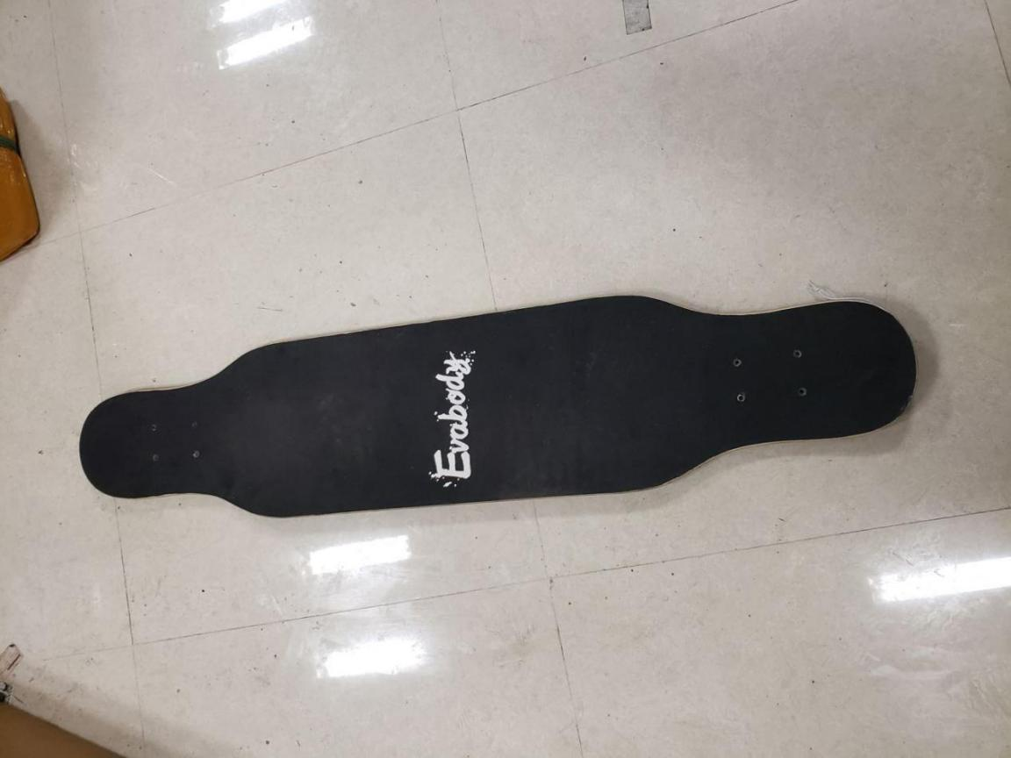
- OHD CANCZ062687
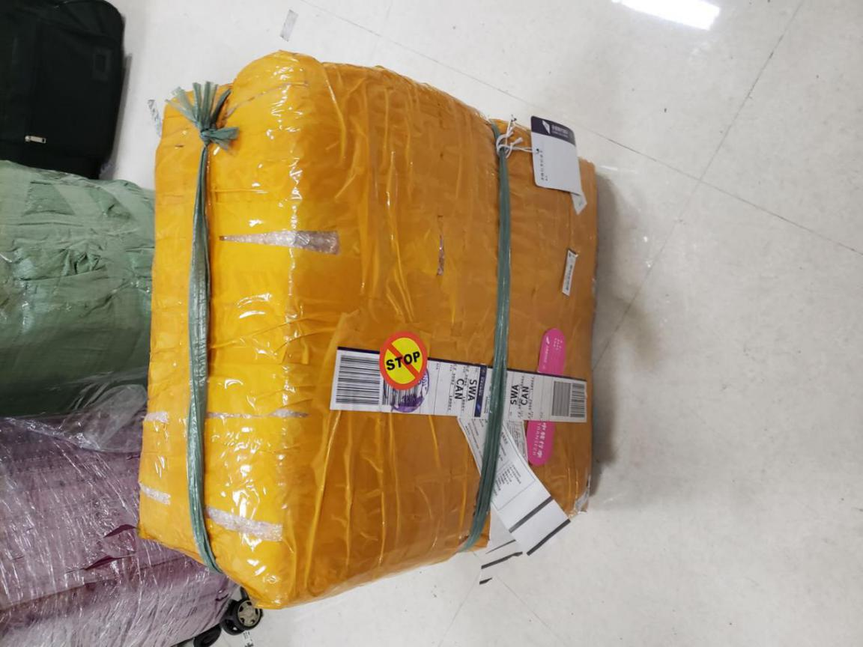
- OHD CANCZ062014
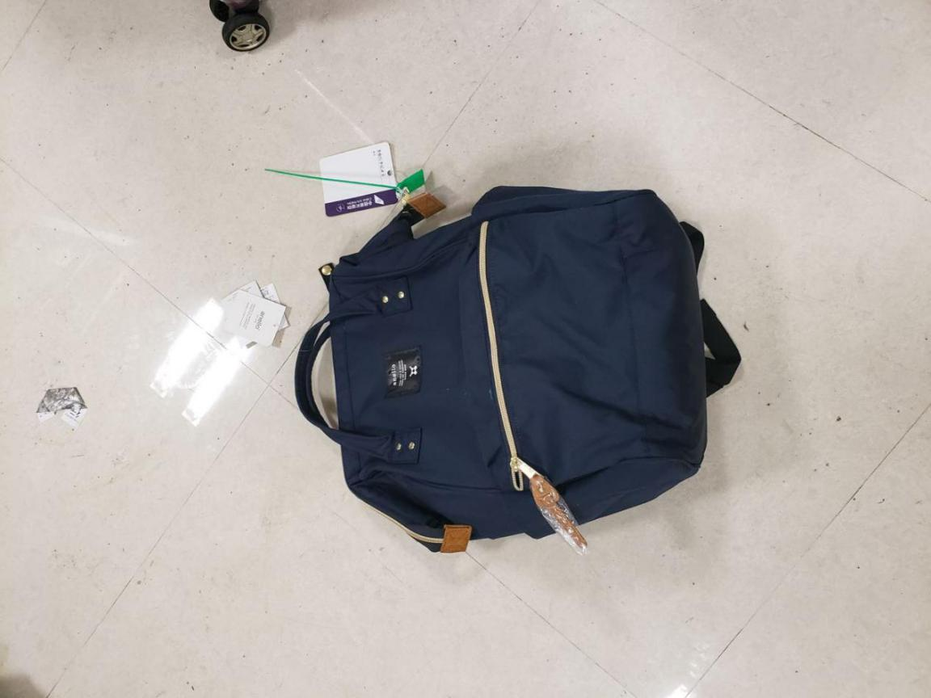
- OHD CANCZ063930
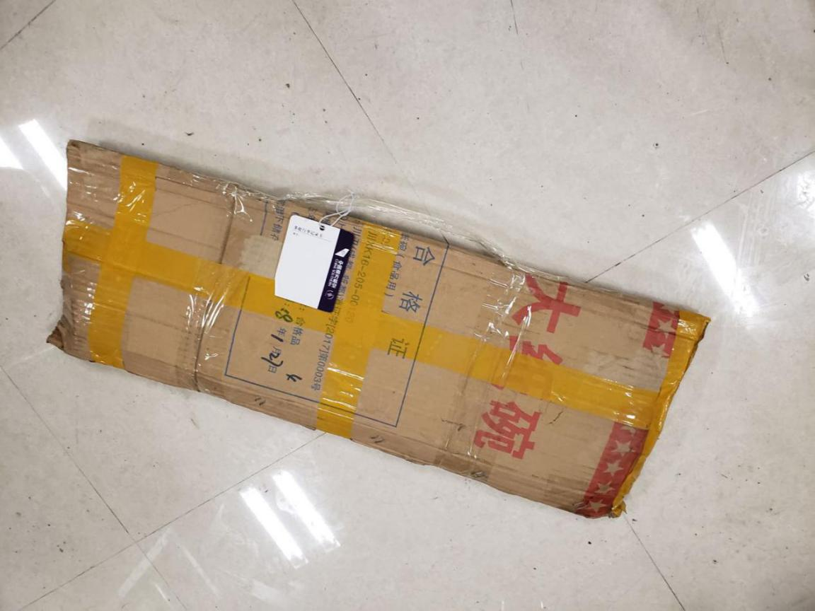
- OHD CANCZ063742
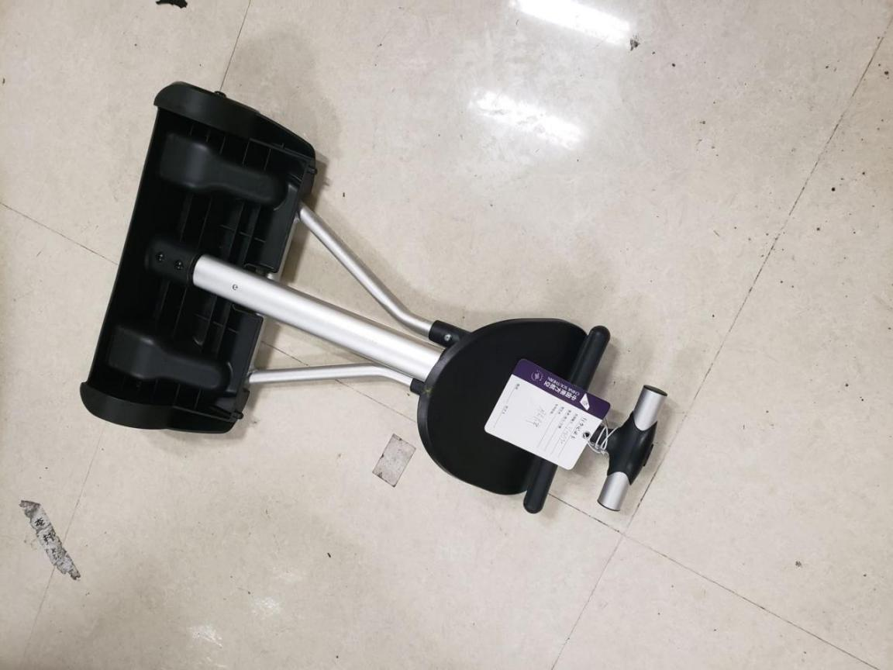
- OHD CANCZ064925
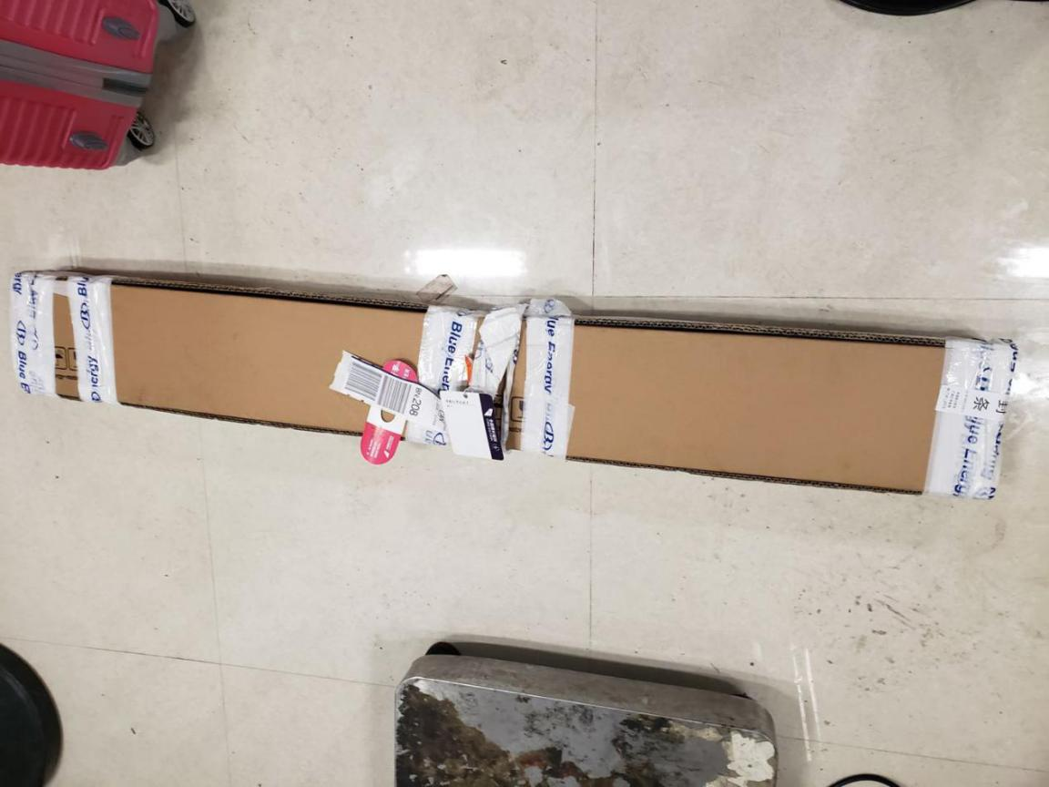
- OHD CANCZ064222
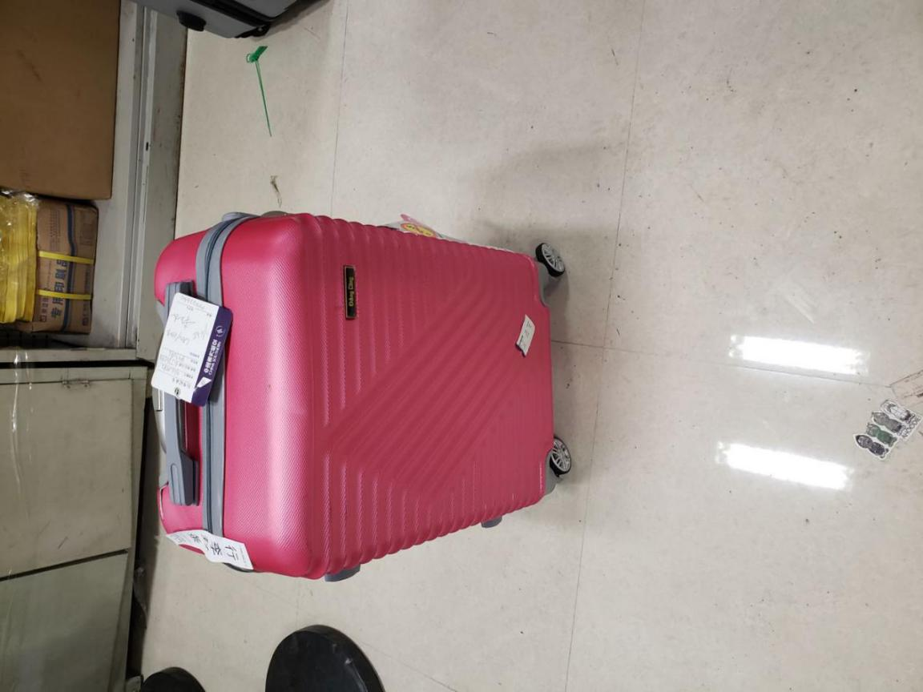
- OHD CANCZ063659 TN CZ219996
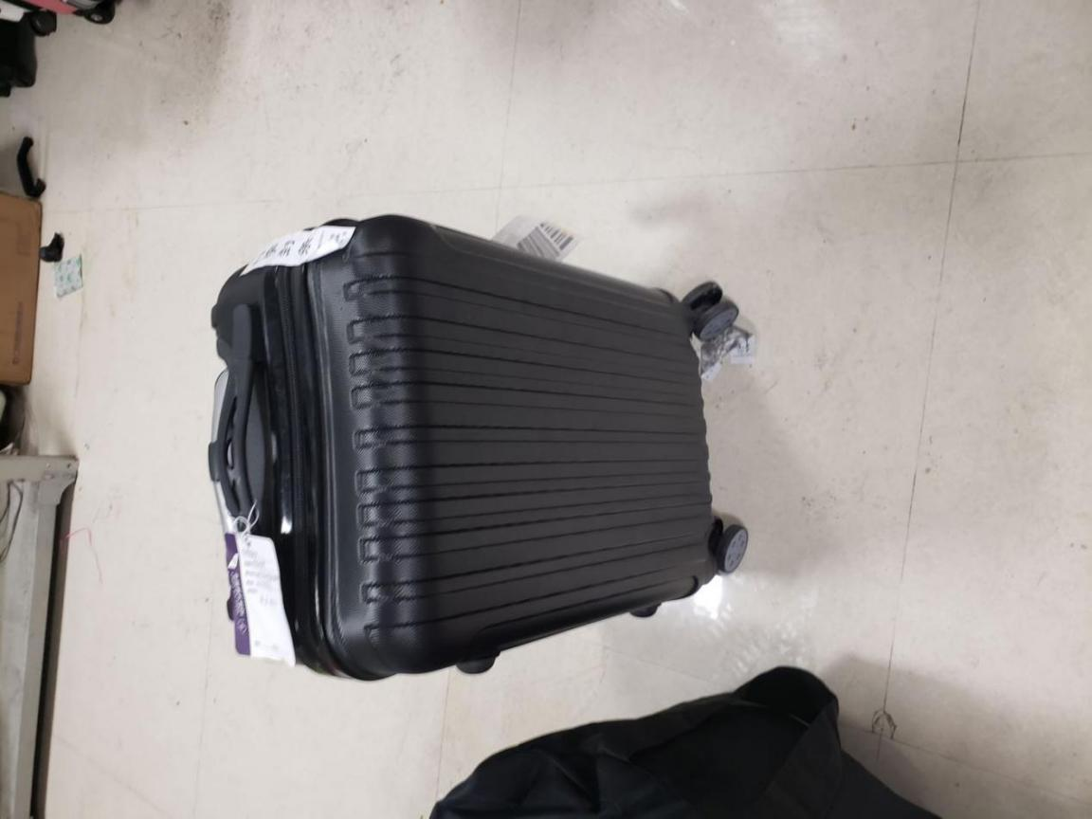
- OHD CANCZ062676 TN CZ240490
- OHD CANCZ062233
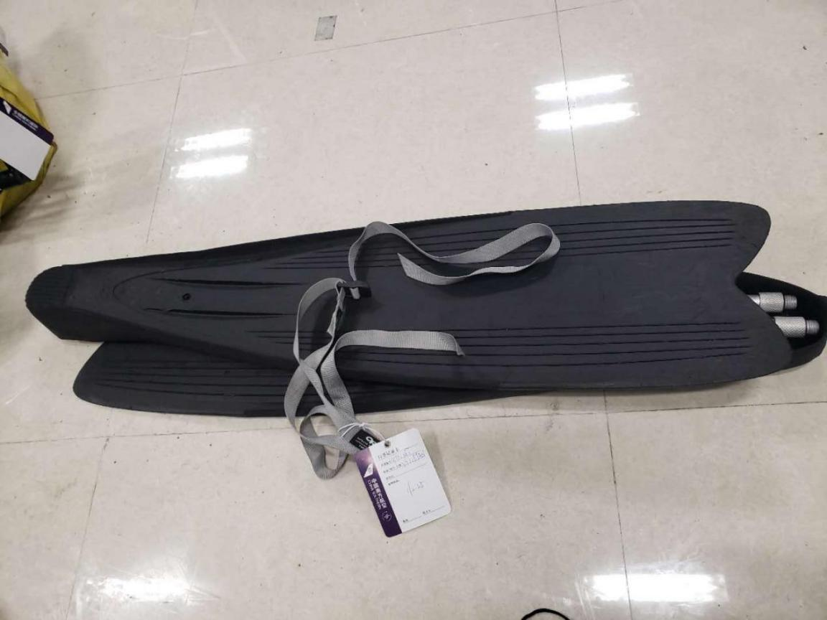
- OHD CANCZ062169 TN CZ020646
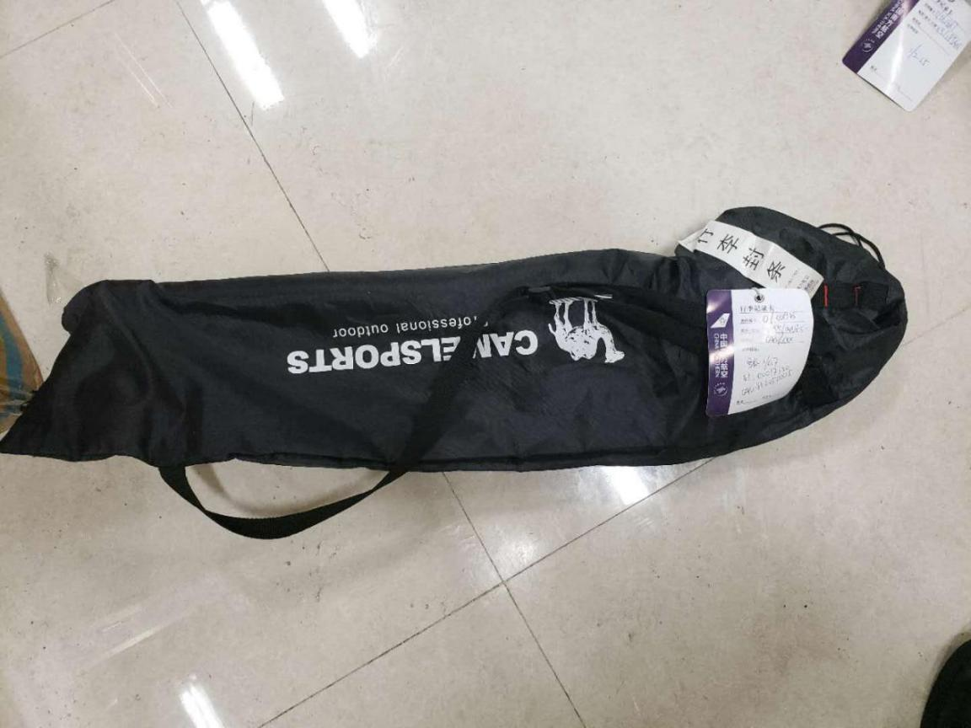
- OHD CANCZ063824
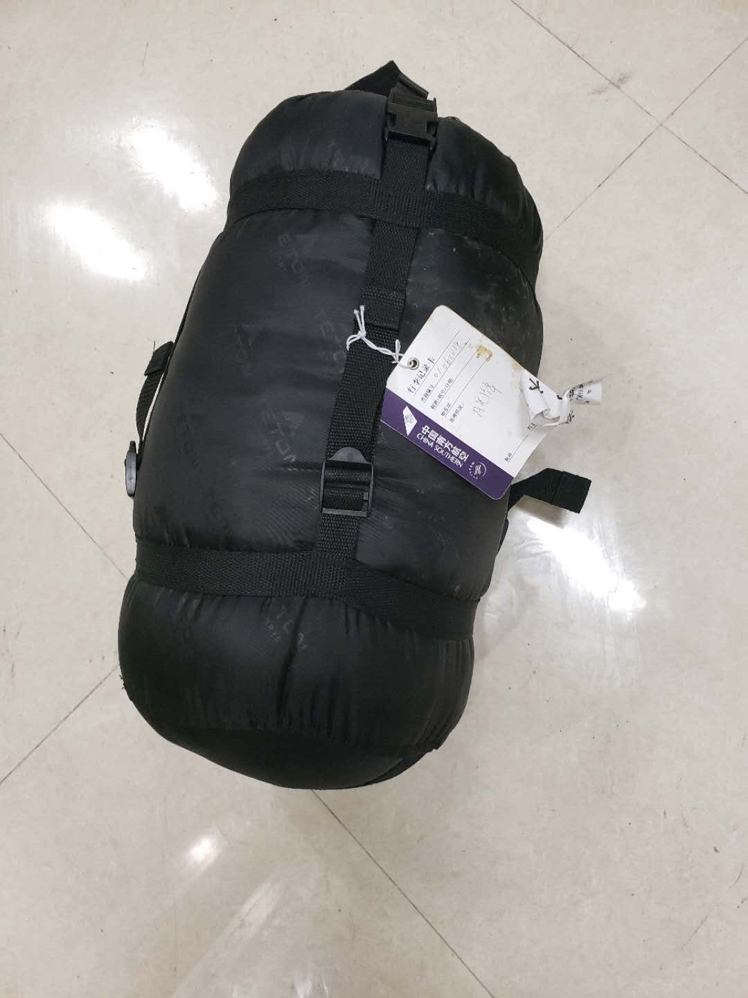
- OHD CANCZ062714
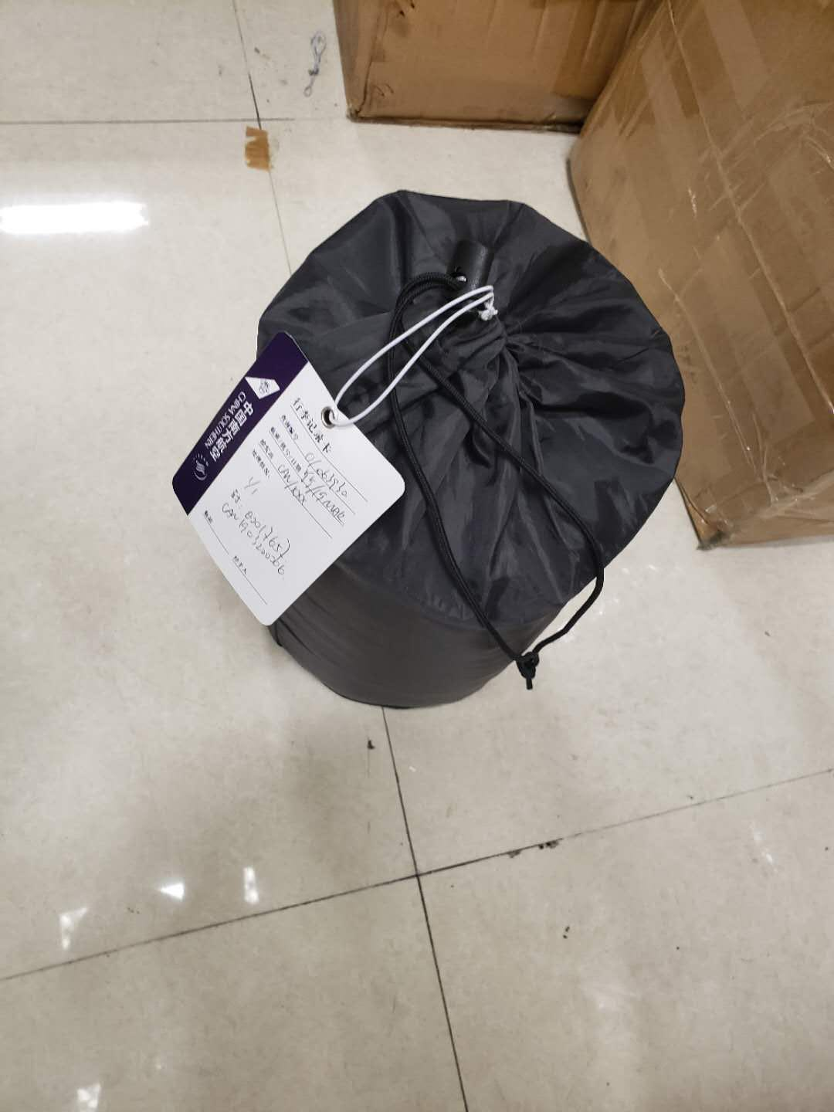
- OHD CANCZ063190
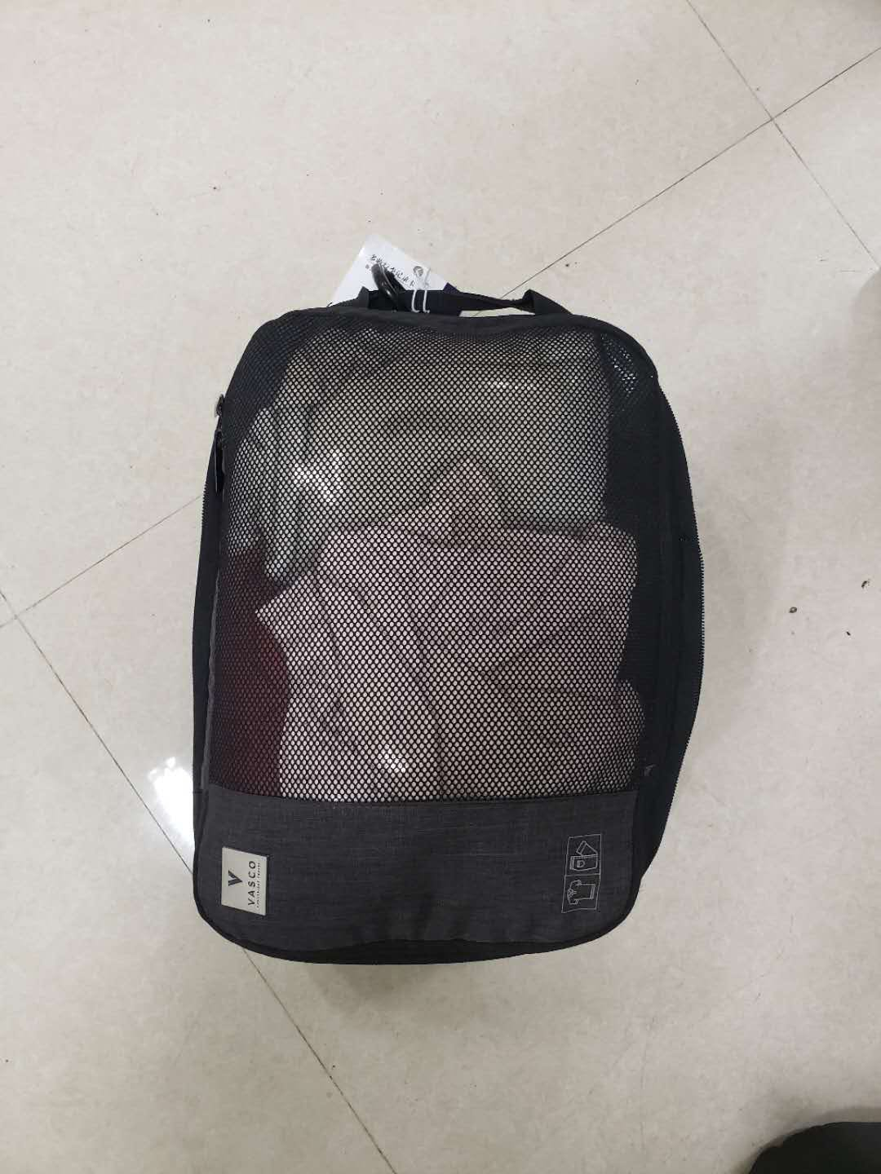
- OHD CANCZ90406 TN CZ212730
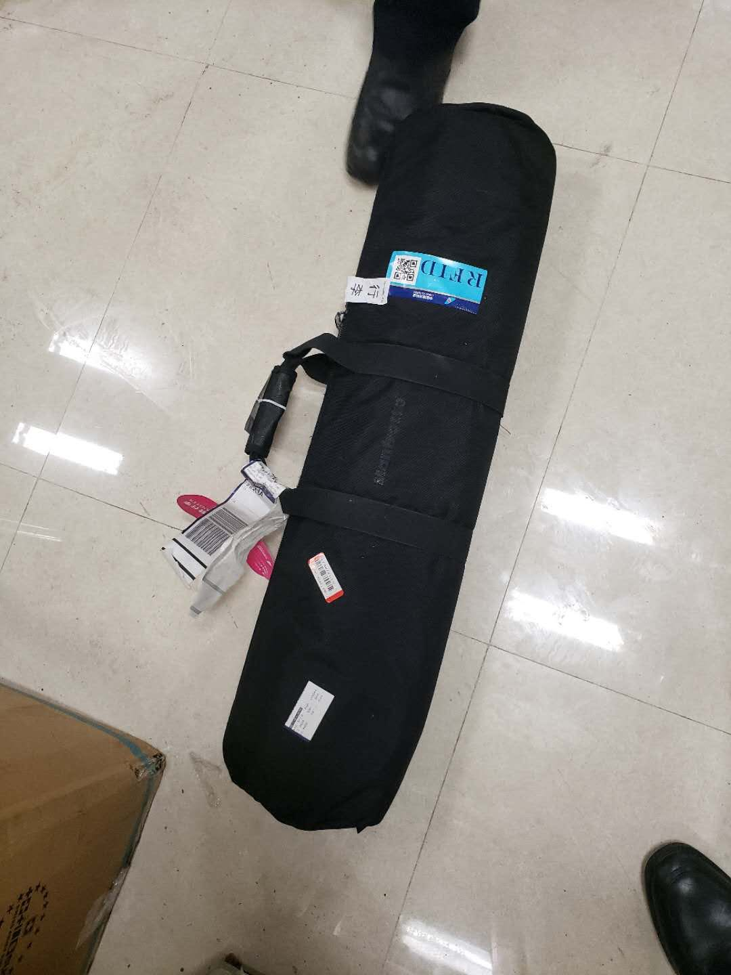
- OHD CANCZ062949 TN CZ024873
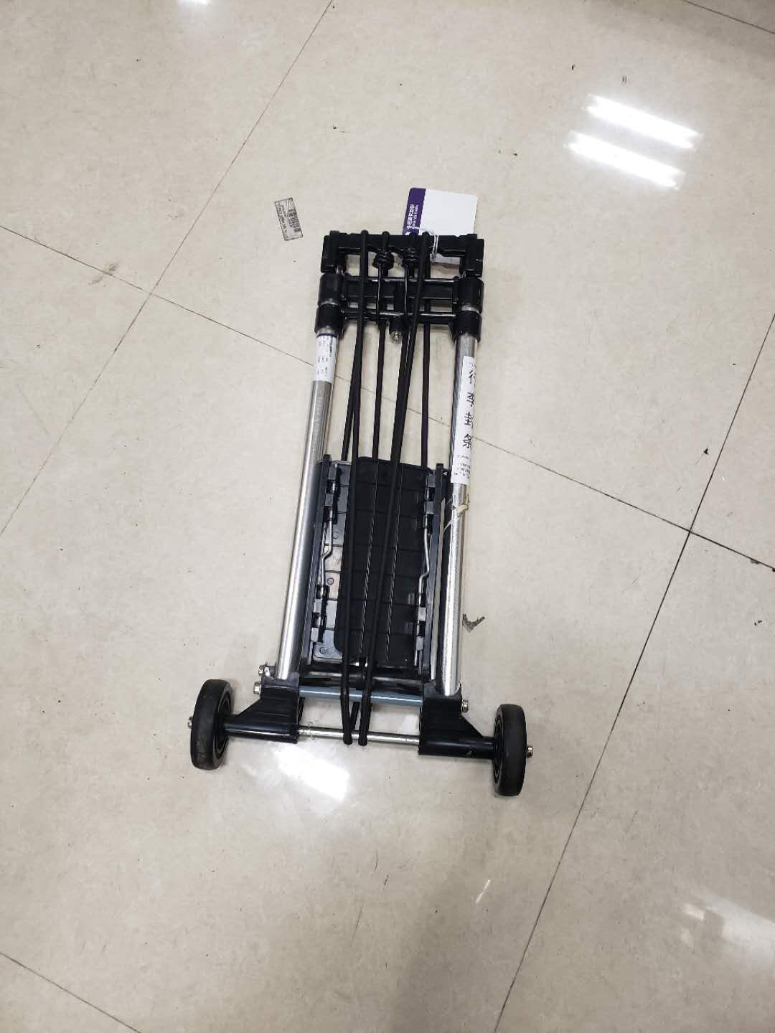
- OHD CANCZ062982 TN CZ897296
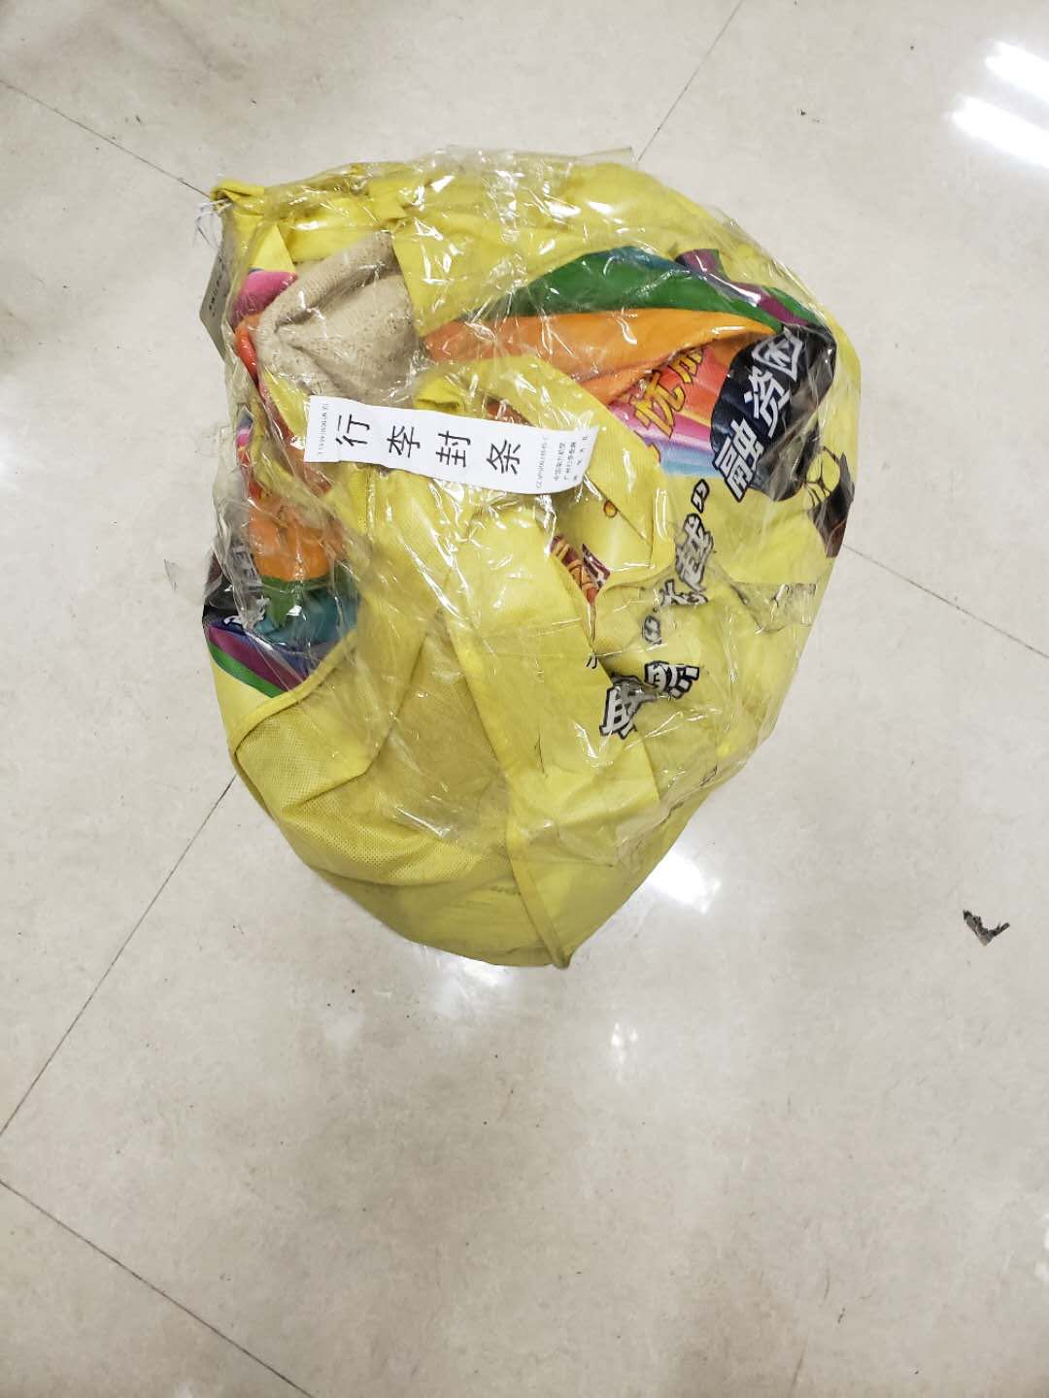
- OHD CANCZ064503
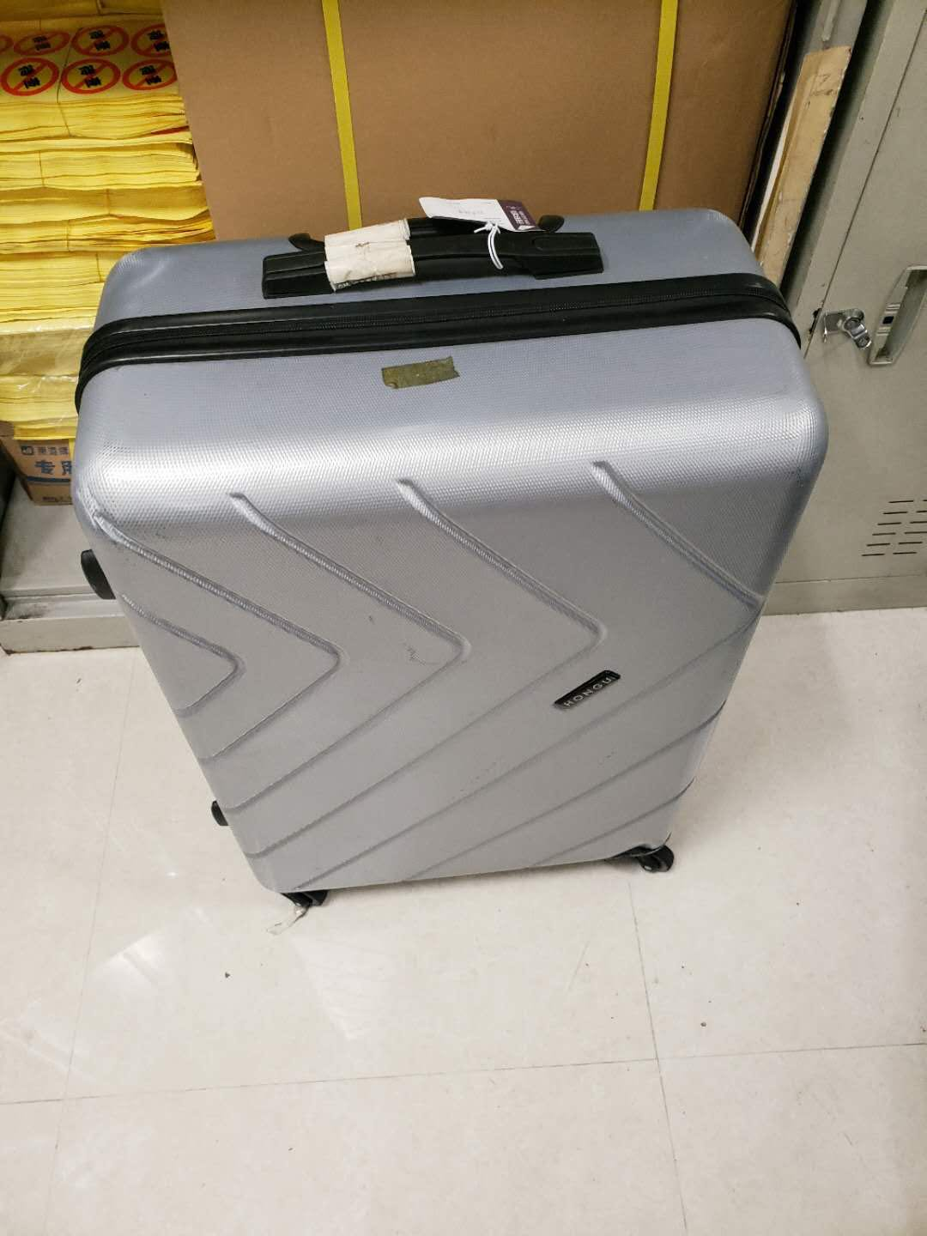
- OHD CANCZ063754 TN CZ542631
- OHD CANCZ89633 TN 011802
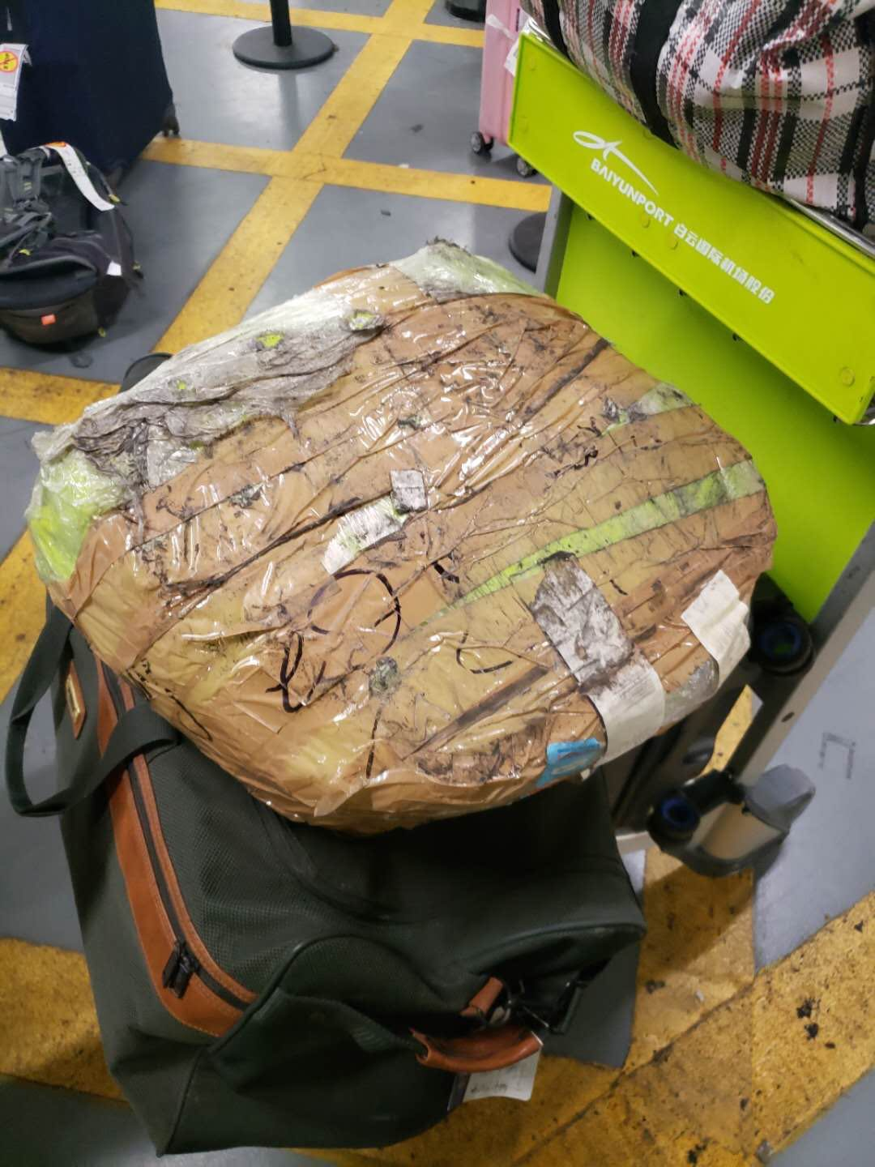
- OHD CANCZ062329 TN CZ500231
- OHD CANCZ89412 TN CZ203555
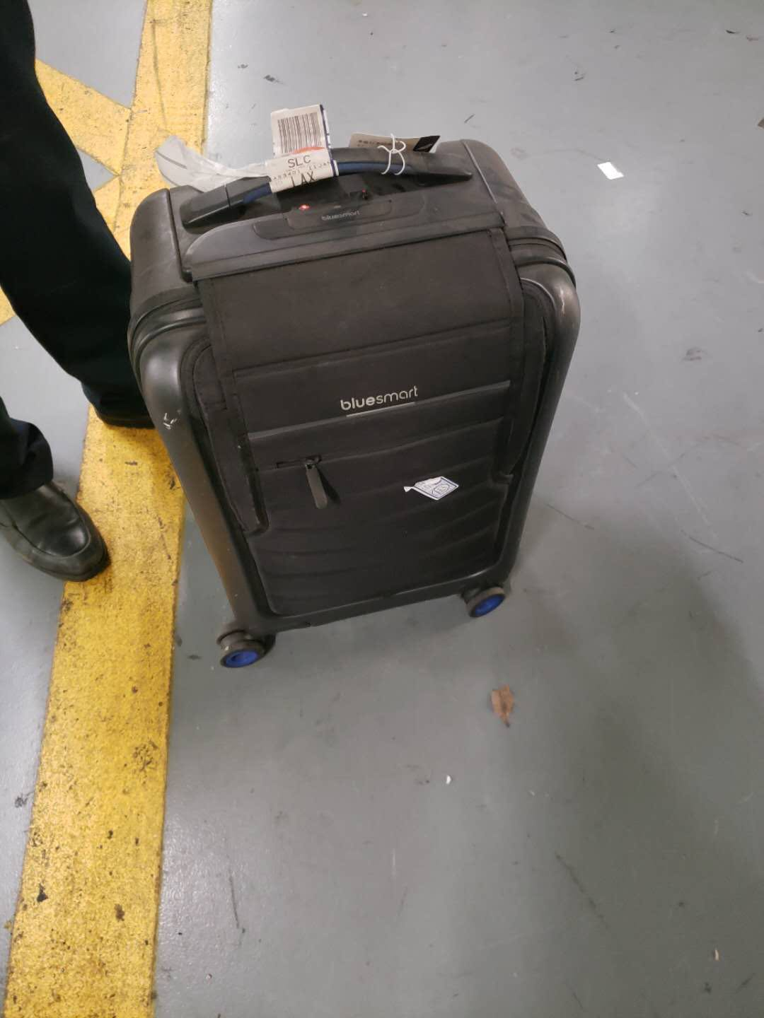
- OHD CANCZ89281 TN CZ269900
